Name - Geetika Kumari

Roll NO - 223064

Subject - COP (java)

Course - PG-DAC

**Index Table: -**

|  |  |  |
| --- | --- | --- |
| Sno. | Day || Assignment | Page no. |
| 1. | Day-1 & 2 || Assignment -1 | 3 |
| 2. | Day-3 || Assignment –2 | 44 |
| 3. | Day-4 || Assignment-3 | 55 |
| 4. | Day-6 || Assignment-4 | 101 |

**Day-1 & 2 || Assignment -1**

PROGRAM 1: -

Write program to test Hello World.

SOURCE CODE :-

public class Hello_1 {

public static void main(String[] args) {

System.out.println("Hello World.");

}

}

OUTPUT : -

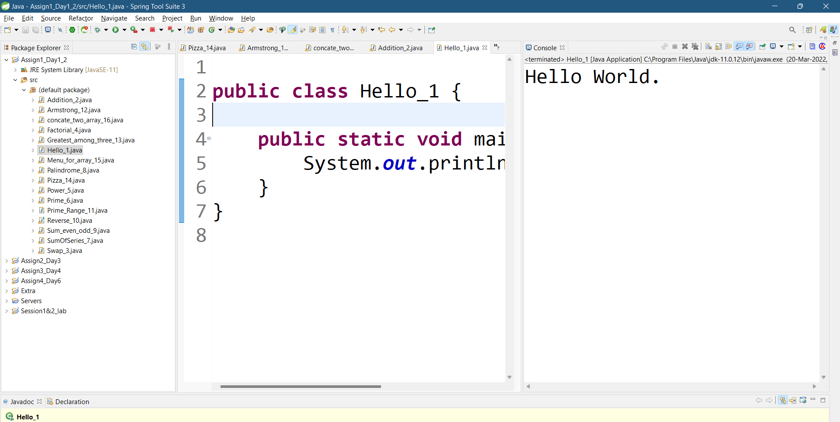

PROGRAM 2 :-

Write a program to adddition of two numbers .

SOURCE CODE :-

import java.util.Scanner;

public class Addition_2 {

public static void main(String[] args) {

System.out.println("Enter two number for addition :-");

Scanner sc=new Scanner(System.in);

int num1=sc.nextInt();

int num2=sc.nextInt();

int num3=num1+num2;

System.out.println("Addition : -");

System.out.println(num1+" + "+num2+" = "+num3);

}

}

OUTPUT :-

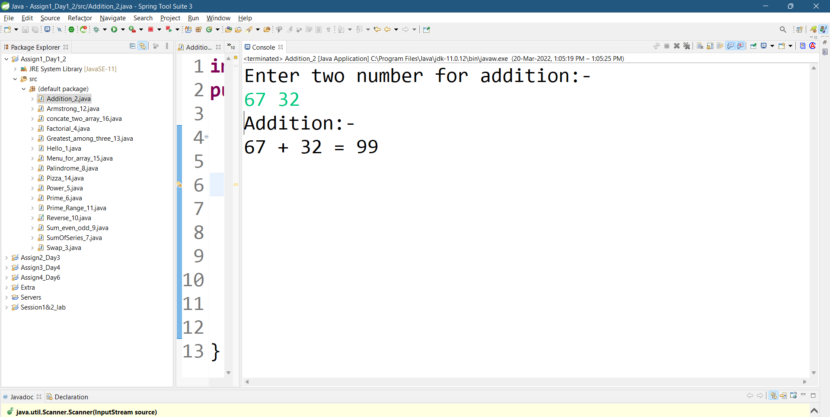

PROGRAM 3 :-

Write a program to swap two numbers.

SOURCE CODE :-

import java.util.Scanner;

public class Swap_3 {

public static void main(String[] args) {

System.out.println("Enter two number for Swapping:-");

Scanner sc=new Scanner(System.in);

int num1=sc.nextInt();

int num2=sc.nextInt();

System.out.println("Before Swapping:-");

System.out.println("Number 1 = "+num1+ " Number 2 = "+num2);

int num3=num1;

num1=num2;

num2=num1;

System.out.println("After Swapping:-");

System.out.println("Number 1 = "+num1+ " Number 2 = "+num2);

}

}

OUTPUT :-

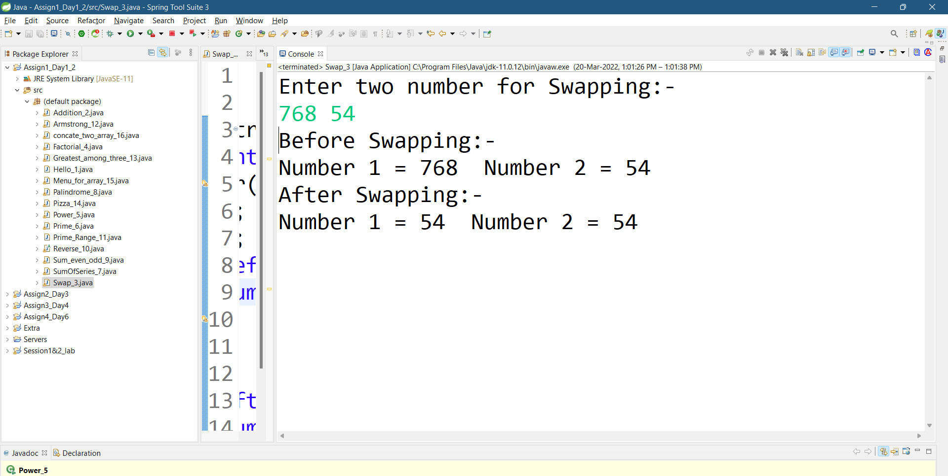

PROGRAM 4 :-

Write a program to find factorial of a given number.

SOURCE CODE :-

import java.util.Scanner;

public class Factorial_4 {

public static void main(String[] args) {

System.out.println("Enter Number for factorial:-");

Scanner sc=new Scanner(System.in);

int num1=sc.nextInt();

int f=1;

for(int i=num1;i>=1;i--)

f=f*i;

System.out.println("Factorial of "+num1+"!"+" = "+f);

}}

OUTPUT :-

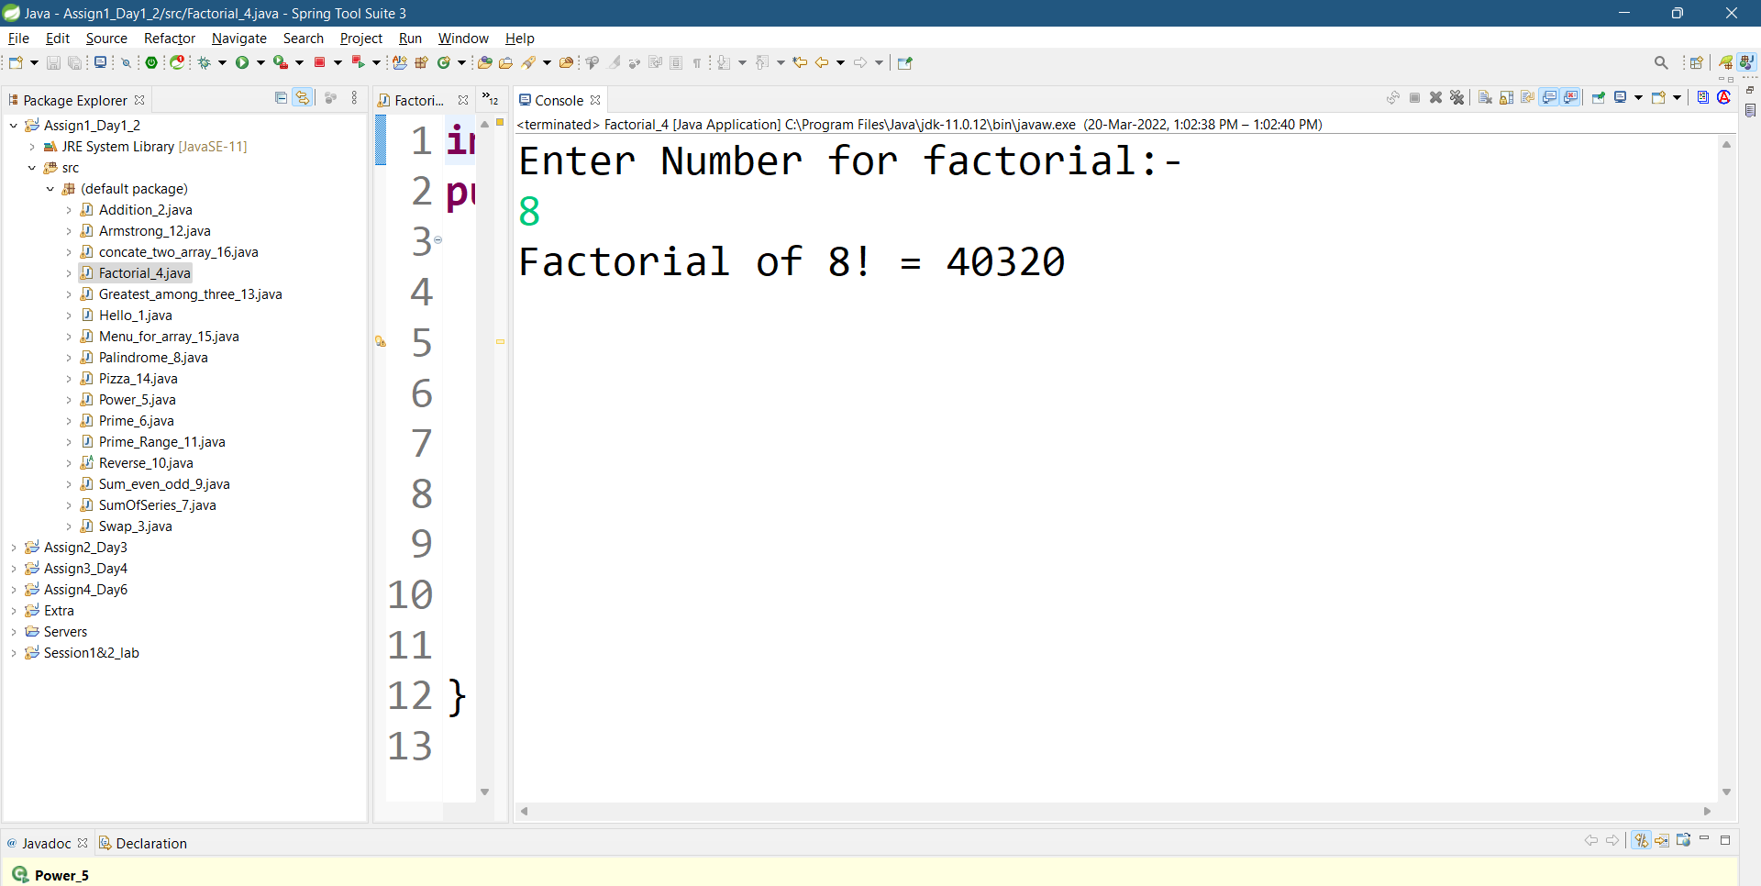

PROGRAM 5 :-

Write a program to find m to the power n.

SOURCE CODE :-

import java.util.Scanner;

public class Power_5 {

public static void main(String[] args) {

System.out.println("Enter two number for x raise to power to n(x^n):-");

Scanner sc=new Scanner(System.in);

int num1=sc.nextInt();

int num2=sc.nextInt();

int f=1;

for(int i=1;i<=num2;i++)

f=f*num1;

System.out.println(num1+"^"+num2+" = "+f);

}}

OUTPUT :-

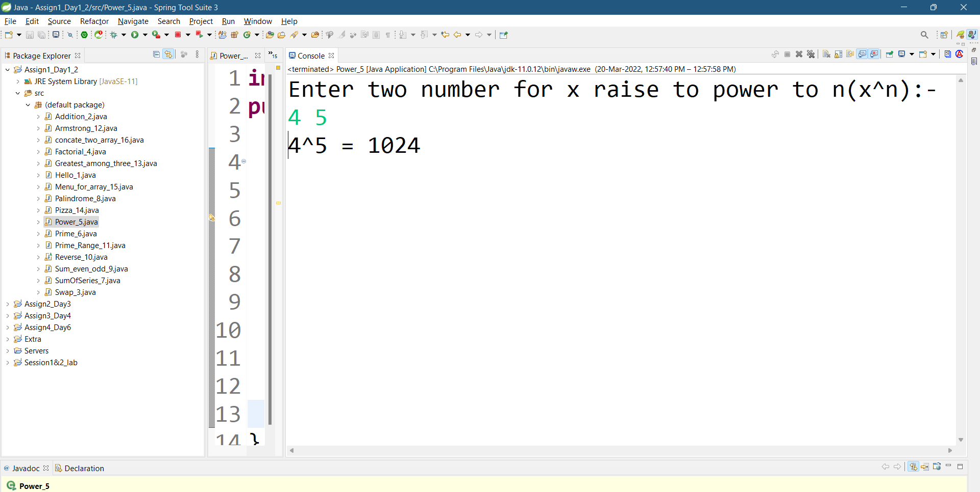

PROGRAM 6 :-

Check if number is a prime number or not.

SOURCE CODE :-

import java.util.Scanner;

public class Prime_6 {

public static void main(String[] args) {

Scanner sc=new Scanner(System.in);

System.out.println("Enter number to check whether it is prime or not:-");

int num1=sc.nextInt();

int c=0;

for(int i=2;i<num1/2;i++)

if(num1%i==0)

c++;

if(c==0)

System.out.println("It is a prime number.");

else

System.out.println("It is not a prime number.");

}

}

OUTPUT :-

1.check for not prime

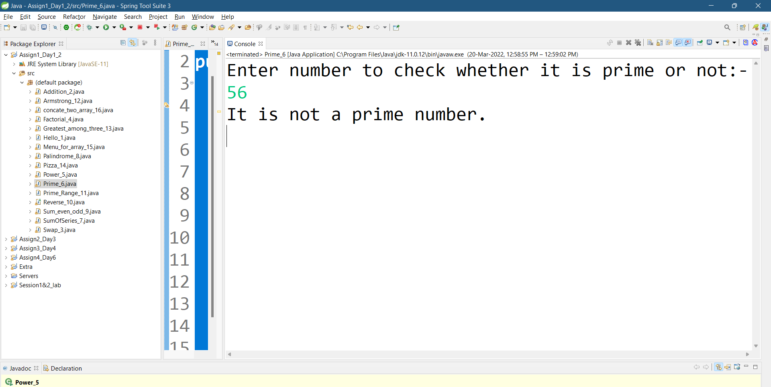

2.check for prime

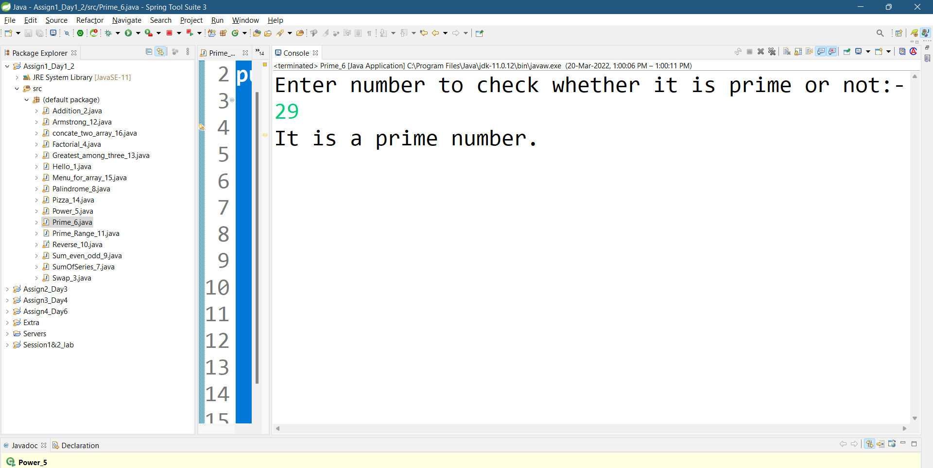

PROGRAM 7 :-

Sum of series :  
 1+2+3+….+n

SOURCE CODE :-

import java.util.Scanner;

public class SumOfSeries_7 {

public static void main(String[] args) {

System.out.println("Enter the number for sum of series:-");

Scanner sc=new Scanner(System.in);

int num1=sc.nextInt();

int sum=0;

for(int i=1;i<=num1;i++)

{

sum=sum+i;

}

System.out.println("Sum of series 1+...+"+num1+" = "+sum);

}

}

OUTPUT :-

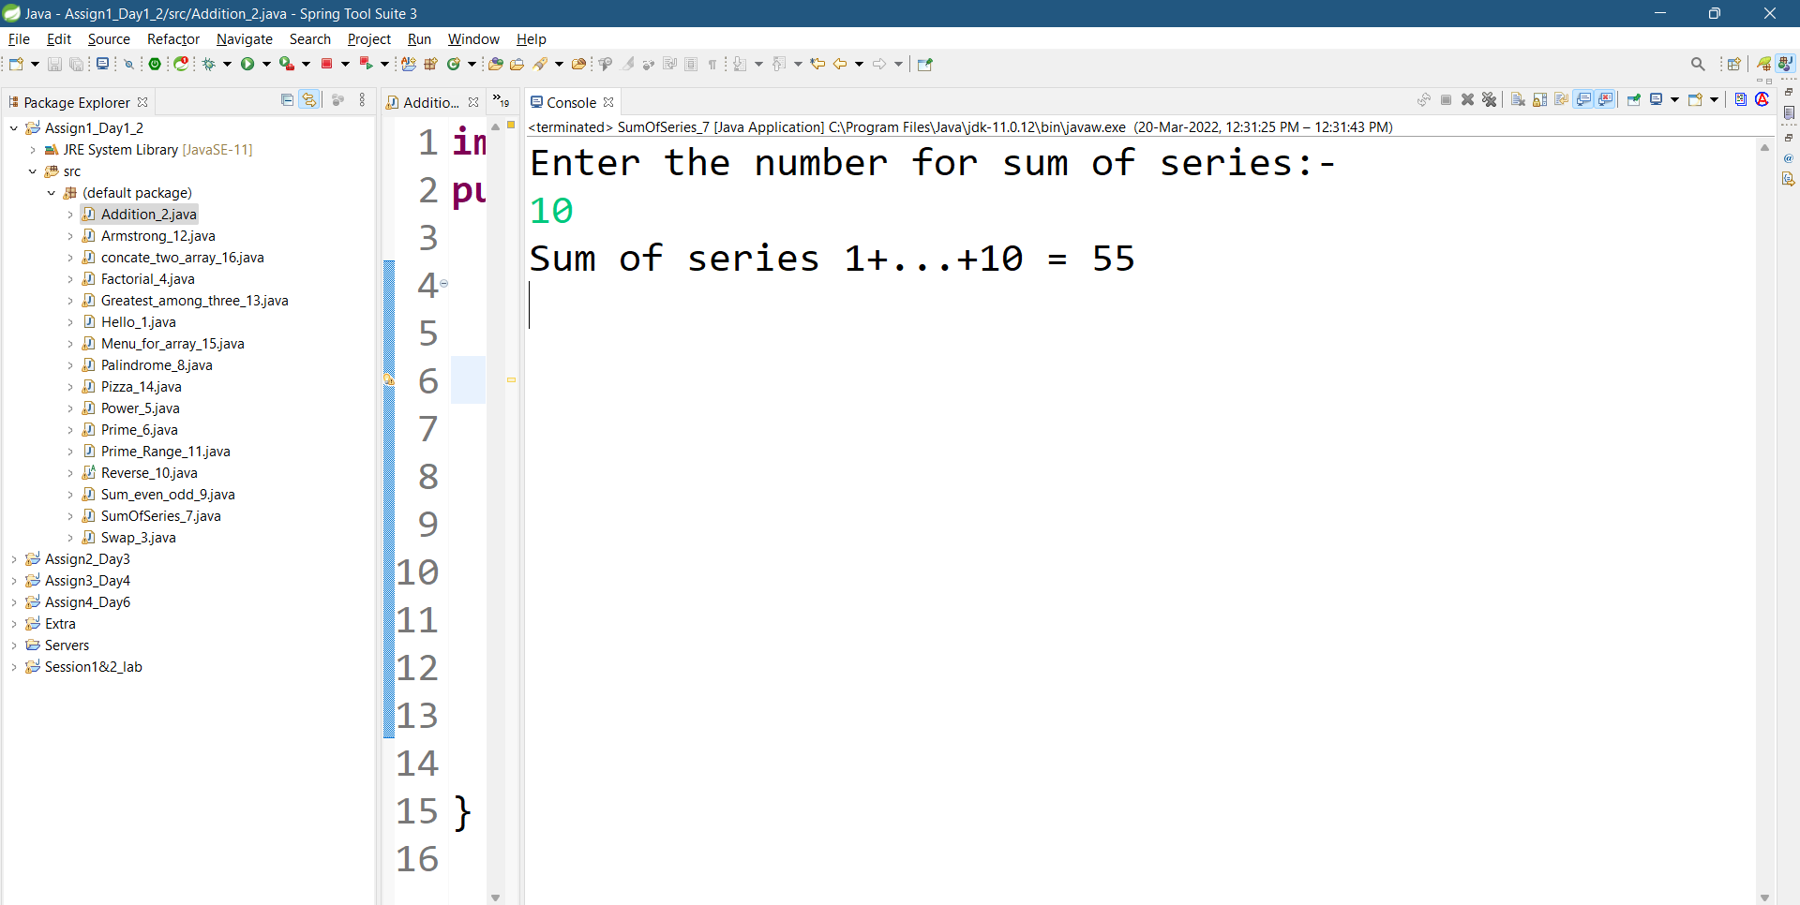

PROGRAM 8 :-

Write a program to check number is palindrome or not.

SOURCE CODE :-

import java.util.Scanner;

public class Palindrome_8 {

public static void main(String[] args) {

System.out.println("Number to check palindrome:-");

Scanner sc=new Scanner(System.in);

int num1=sc.nextInt();

int num2=num1,sum=0,r;

while(num1!=0)

{

r=num1%10;

sum=sum*10+r;

num1=num1/10;

}

if(num2==sum)

System.out.println("Palindrome");

else

System.out.println(" not Palindrome");

}}

OUTPUT :-

1. check palindrome

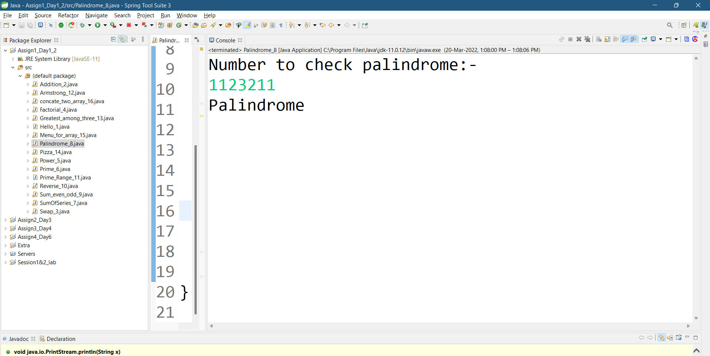

2. check not palindrome

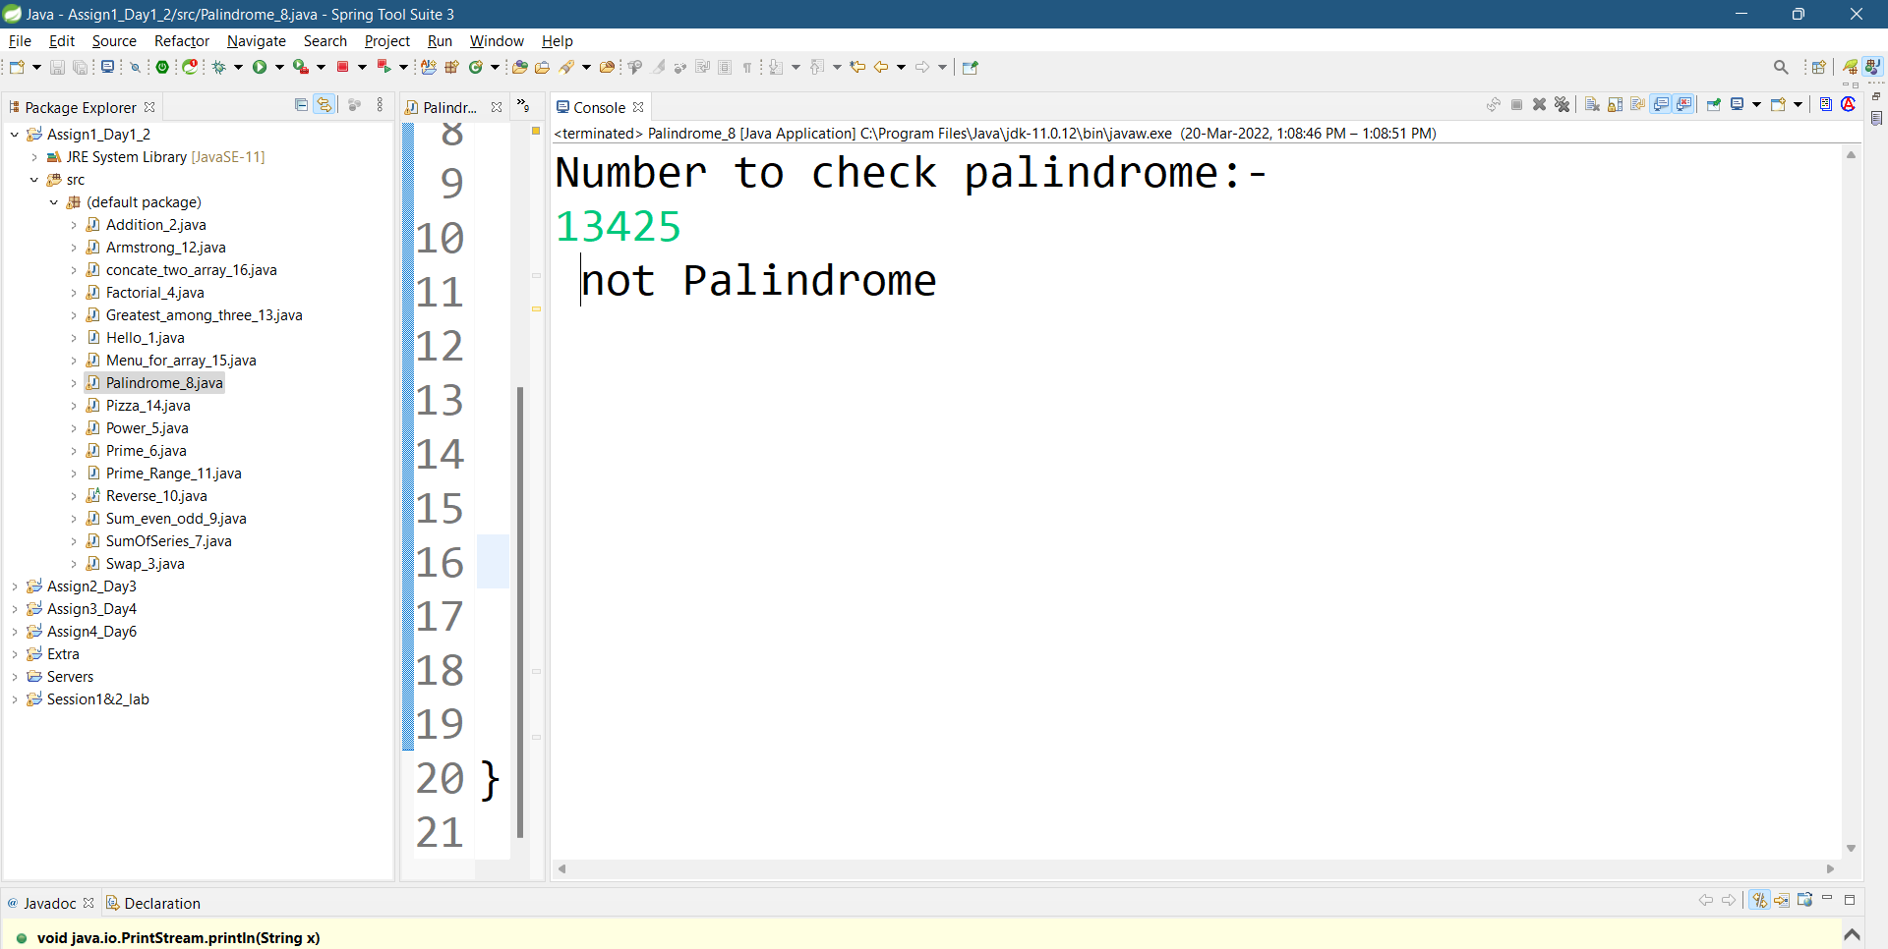

PROGRAM 9 :-

Write a program to find sum of all even and odd numbers between 1 to n.

SOURCE CODE :-

import java.util.Scanner;

public class Sum_even_odd_9 {

public static void main(String[] args) {

System.out.println("Enter the number for sum of series of odd and even number seperately:-");

Scanner sc=new Scanner(System.in);

int num1=sc.nextInt();

int even=0,odd=0,i;

for(i=1;i<=num1;i++) {

if(i%2==0)

even=even+i;

else

odd=odd+i;}

System.out.println("Sum of even series 1+...+"+num1+" = "+even);

System.out.println("Sum of odd series 1+...+"+num1+" = "+odd);

}

}

OUTPUT :-

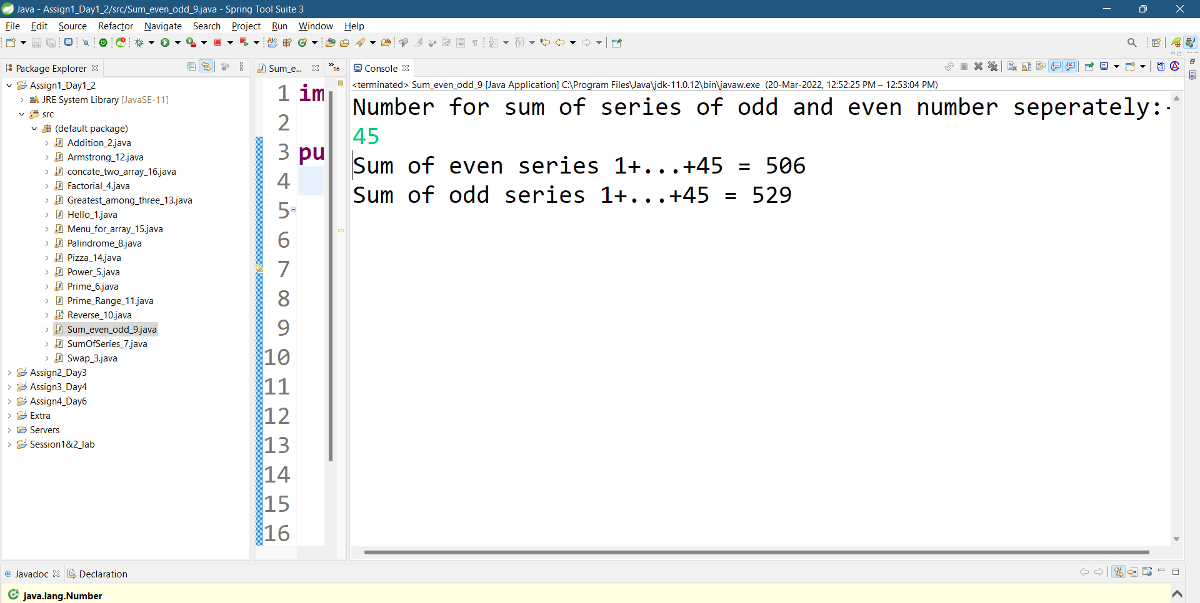

PROGRAM 10 :-

Write a program to enter a number and print its reverse.

SOURCE CODE :-

import java.util.Scanner;

public abstract class Reverse_10 {

public static void main(String[] args) {

System.out.println("Enter the number for reverse:-");

Scanner sc=new Scanner(System.in);

int num1=sc.nextInt();

int r,sum=0;

int num2=num1;

while(num1!=0)

{

r=num1%10;

sum=sum*10+r;

num1=num1/10;

}

System.out.println("Reverse of the "+num2+" is = "+sum);

}

}

OUTPUT :-

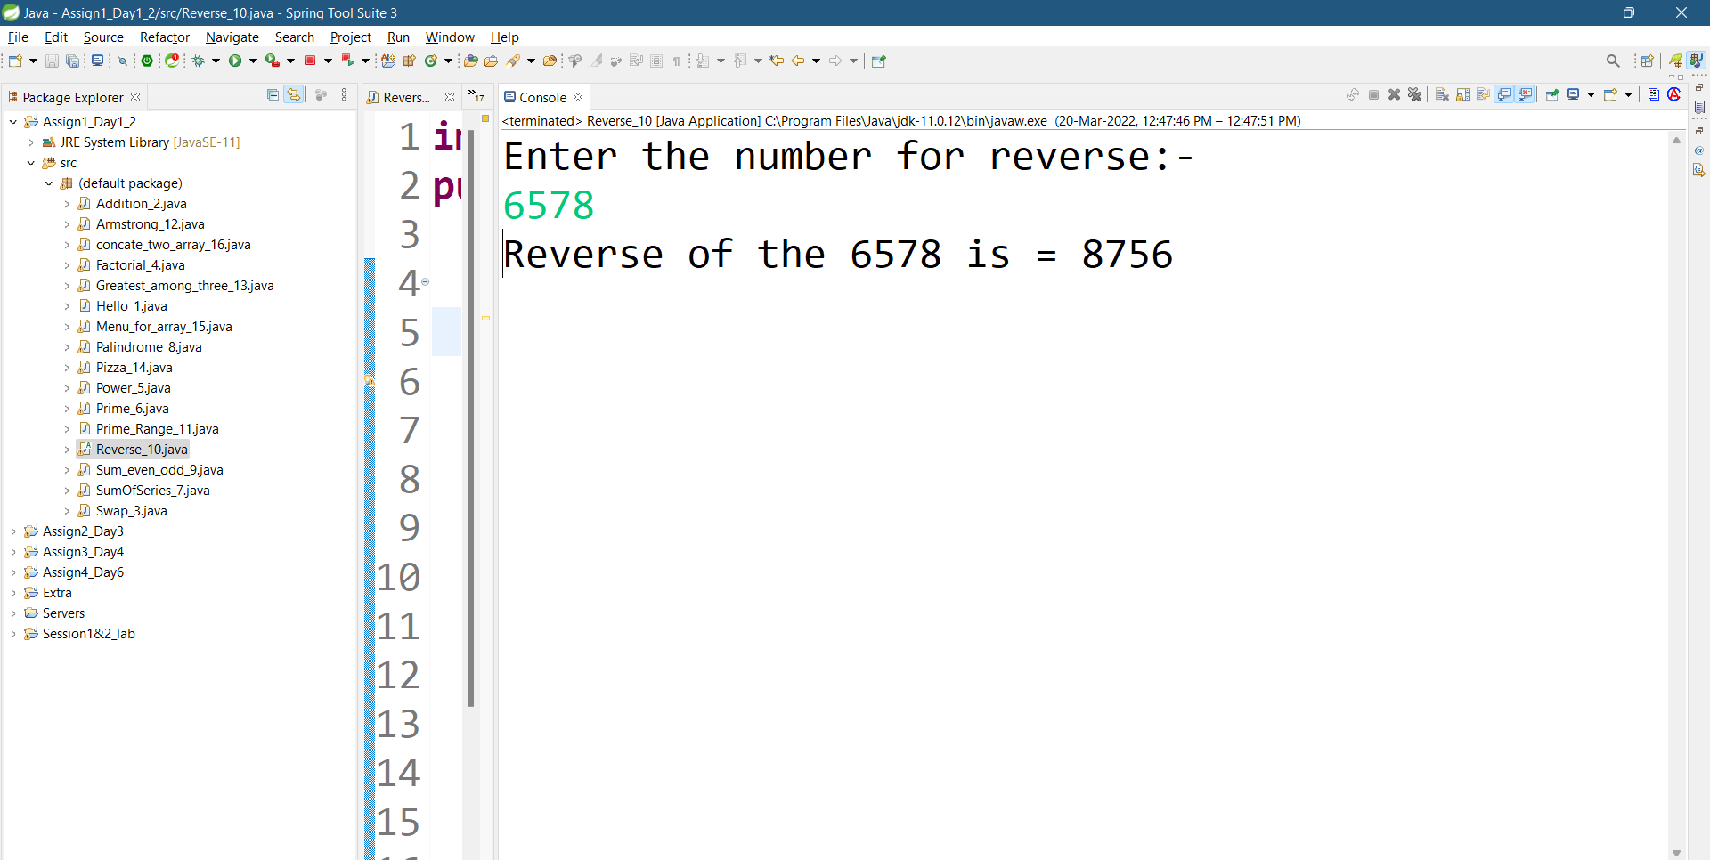

PROGRAM 11 :-

Write a program to print all Prime numbers between 1 to n.

SOURCE CODE :-

import java.util.Scanner;

public class Prime_Range_11 {

public static void main(String[] args) {

System.out.println("Enter the number to find prime in range:-");

Scanner sc=new Scanner(System.in);

int i,c=0,j;

int num1=sc.nextInt();

System.out.println("Prime numbers are in range 1,2,----,"+num1+":-");

for(i=1;i<=num1;i++)

{ c=1;

for(j=2;j<=i/2;j++)

{

if(i%j==0){

c=0;

break;

}}

if(c==1)

System.out.println(i+" ");

}}}

OUTPUT :-

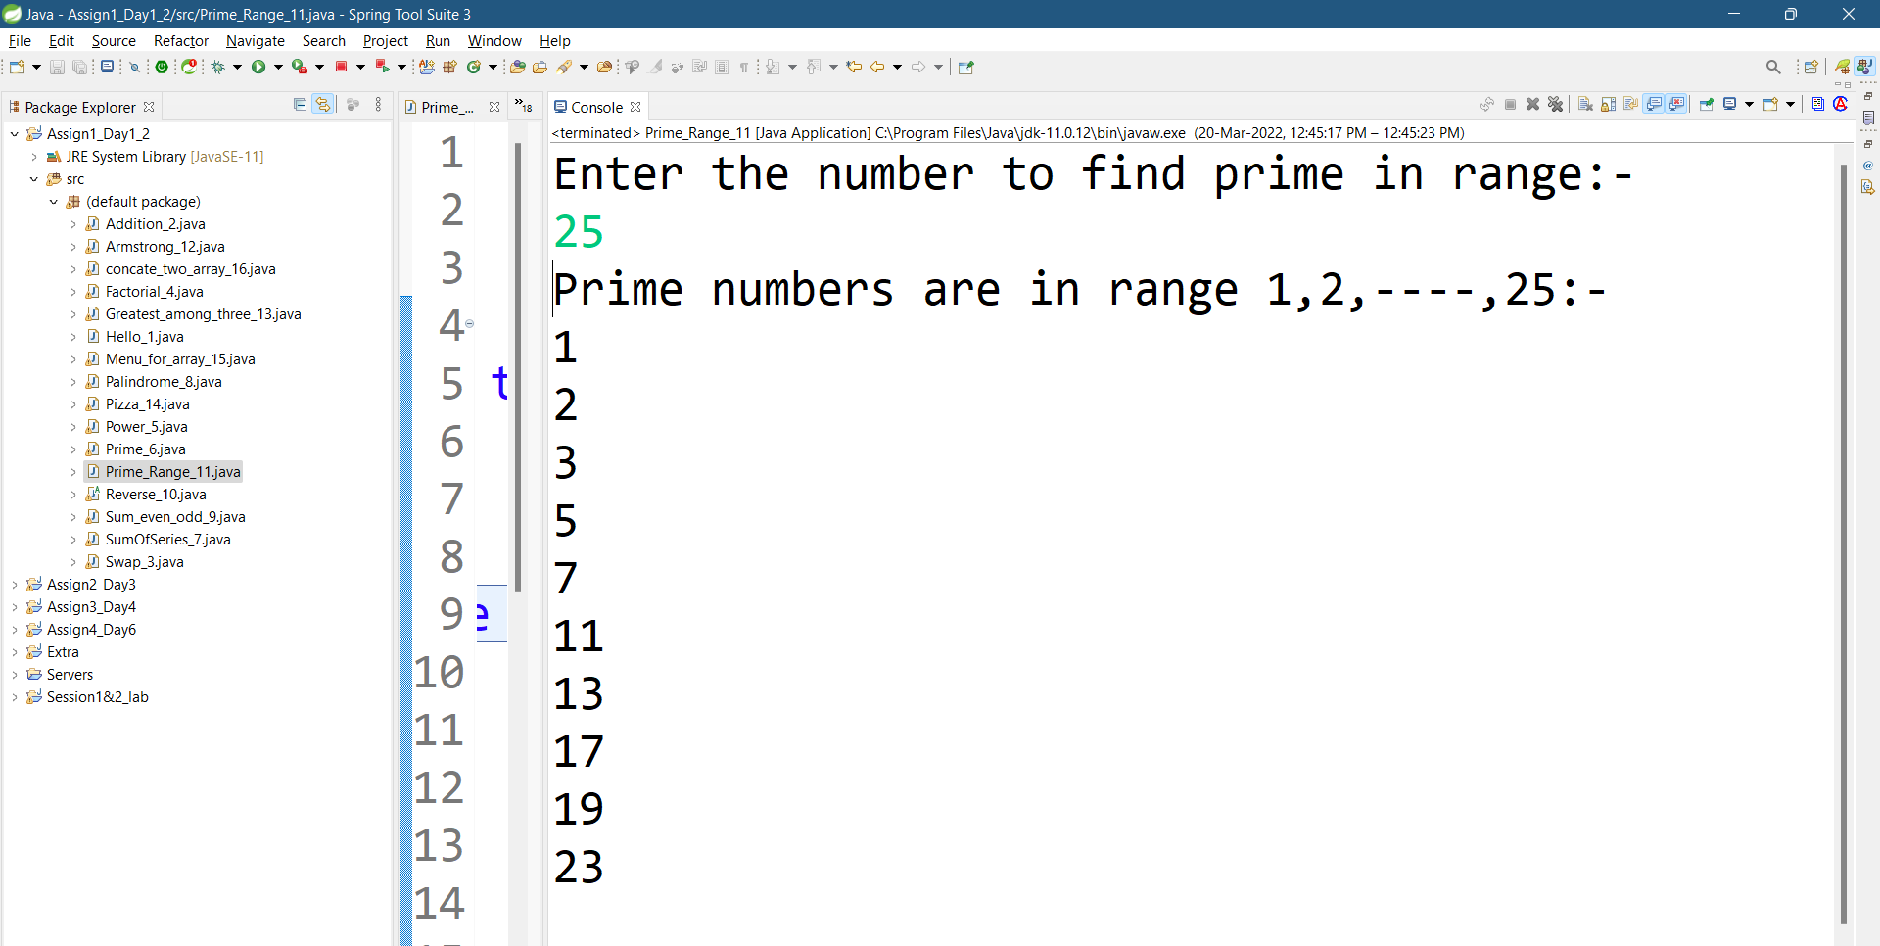

PROGRAM 12 :-

Write a program to check entered number is Armstrong number or not.

SOUCRCE CODE :-

import java.util.Scanner;

public class Armstrong_12 {

public static void main(String[] args) {

System.out.println("Enter the number to check armstrong:-");

Scanner sc=new Scanner(System.in);

int num1=sc.nextInt();

int r,sum=0;

int num2=num1;

while(num1!=0)

{

r=num1%10;

sum=sum+r*r*r;

num1=num1/10;

}

if(sum==num2)

System.out.println(num2+" is an armstrong number.");

else

System.out.println(num2+" is not an armstrong number.");

}

}

OUTPUT :-

1. Check not an armstrong number

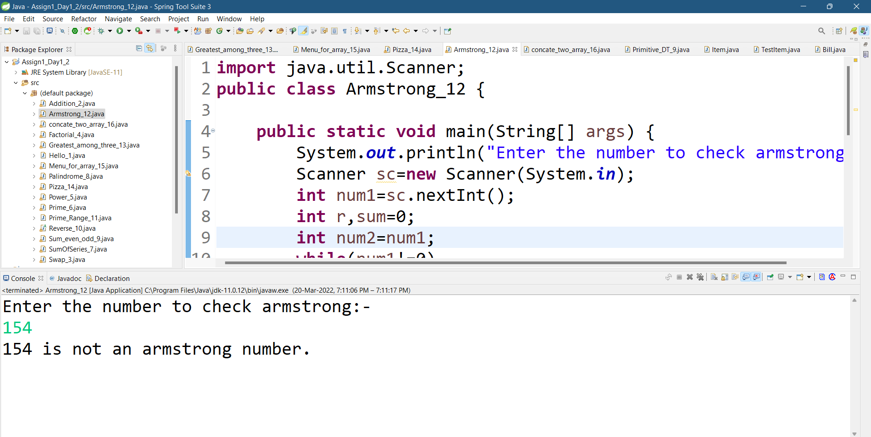

2.Check an armstrong number

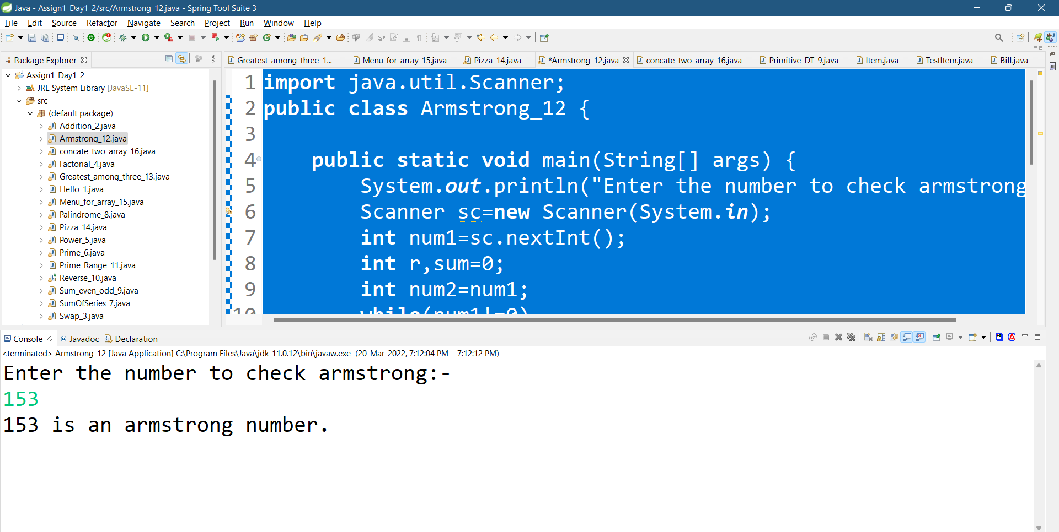

PROGRAM 13 :-

Write a program to find greatest of three numbers using nested if-else.

SOURCE CODE :-

import java.util.Scanner;

public class Greatest_among_three_13 {

public static void main(String[] args) {

System.out.println("Enter three number to print greatest number among them");

Scanner sc=new Scanner(System.in);

int num1=sc.nextInt();

int num2=sc.nextInt();

int num3=sc.nextInt();

if(num1>num2)

{

if(num1>num3)

System.out.println("Max = "+num1);

else

System.out.println("Max = "+num3);

}

else if(num2>num3)

System.out.println("Max = "+num2);

else

System.out.println("Max = "+num3);

}

}

OUTPUT :-

1. First number is greatest

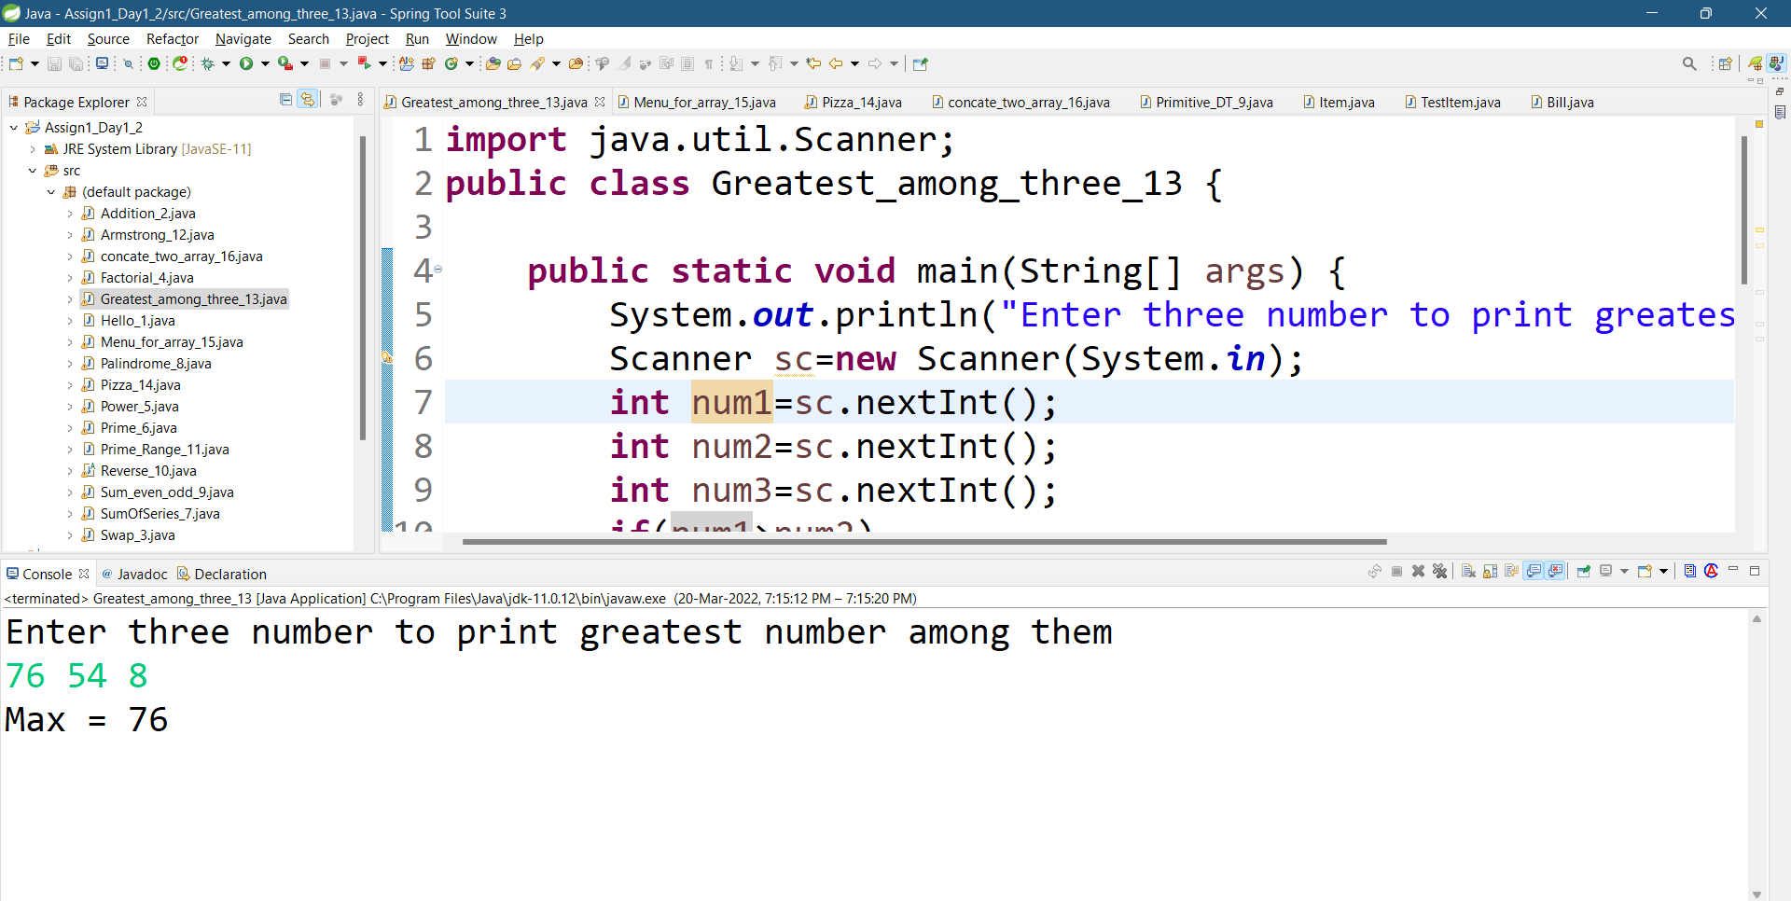

2.Second number is greatest

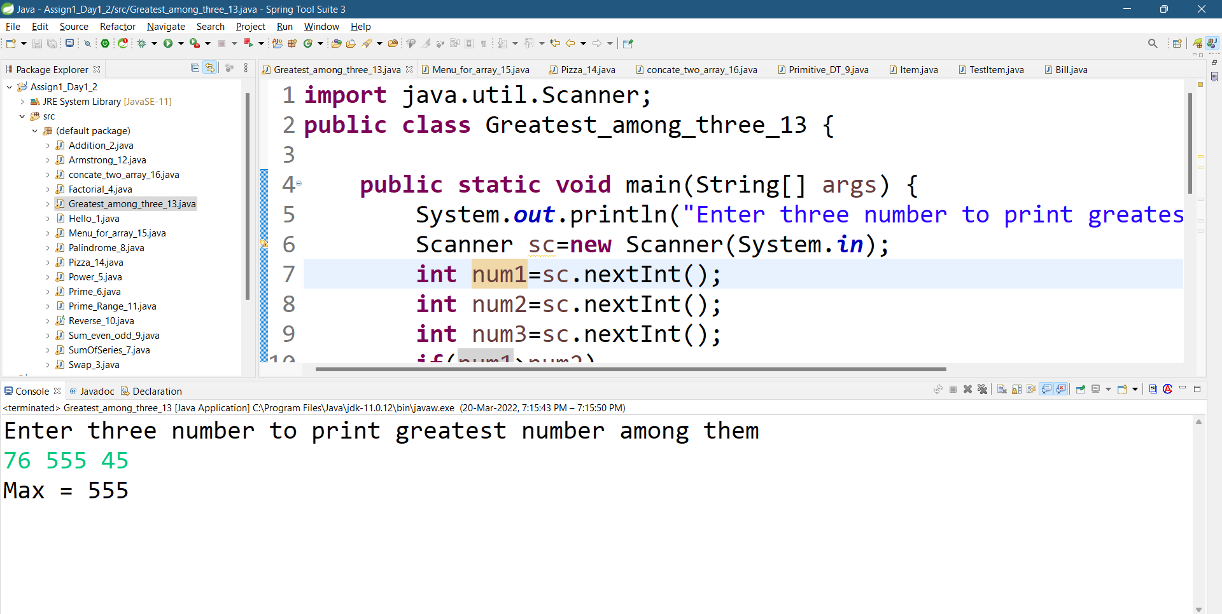

3.Third number is greatest

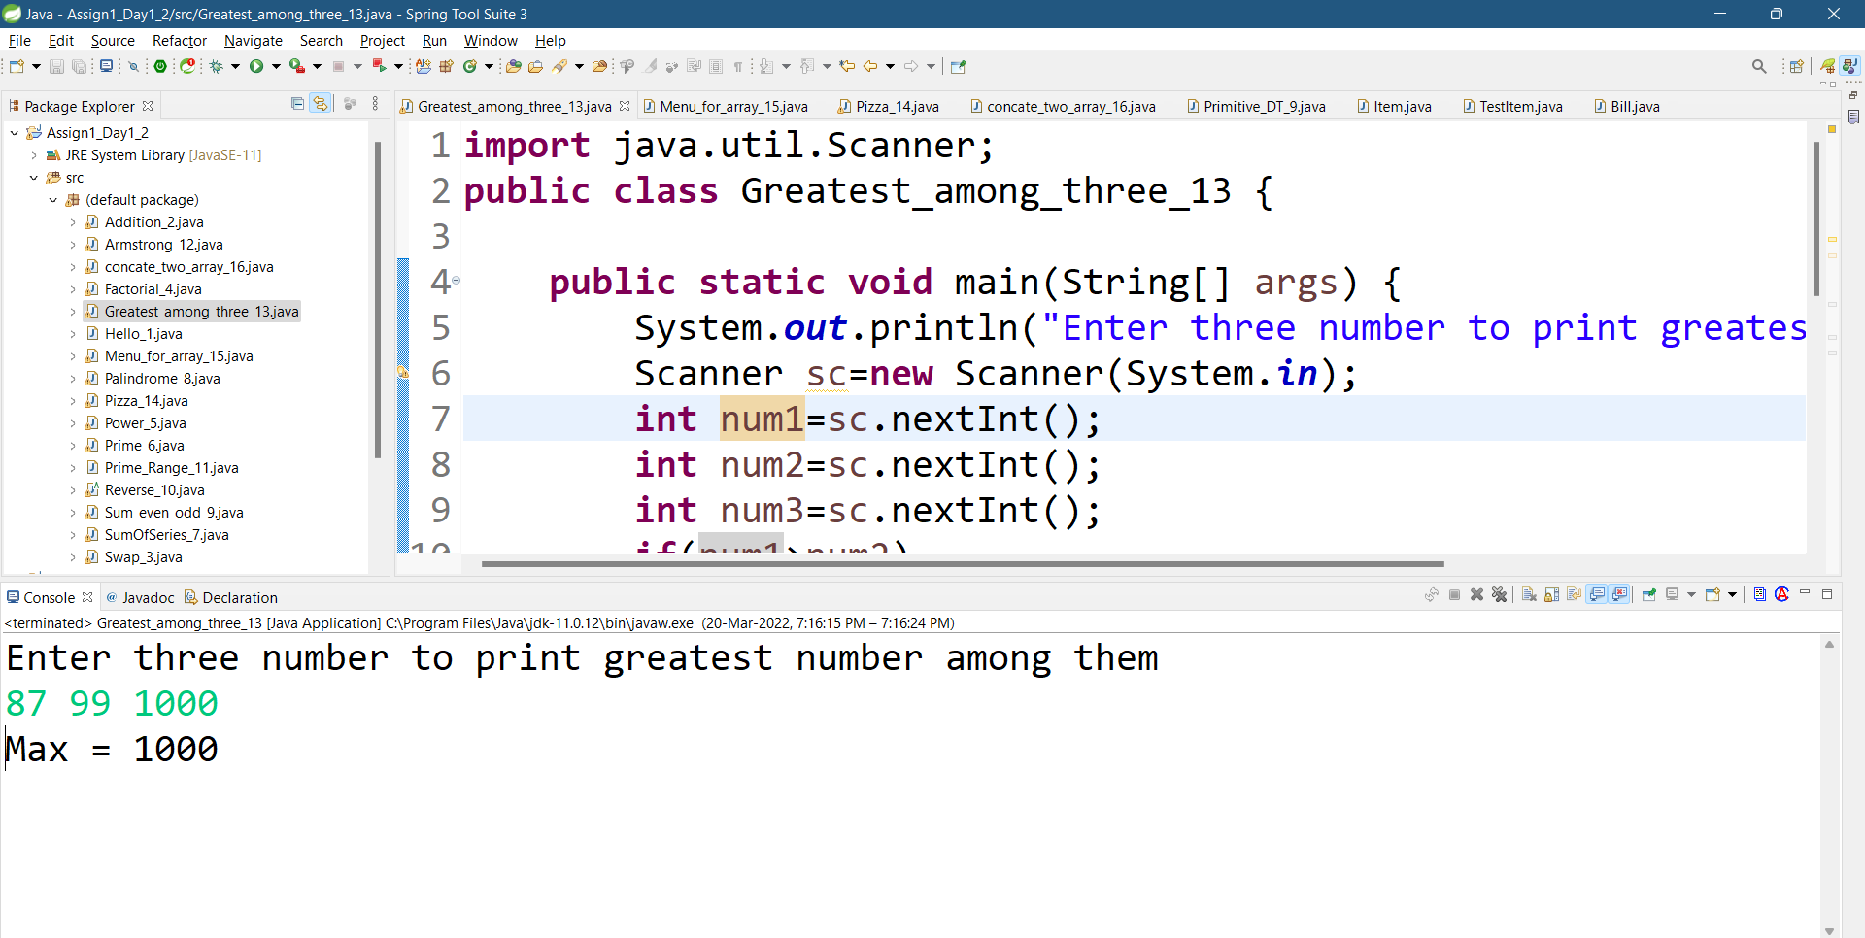

PROGRAM 14 :-

Create menu driven program for Pizza Shop.And display total amount,

SOURCE CODE :-  
import java.util.Scanner;

public class Pizza_14 {

public static void main(String[] args) {

System.out.println("-----Pizza Menu-----");

int sum=0,qty;

String ch1;

Scanner sc=new Scanner(System.in);

boolean di=true; System.out.println("1.\tMagretta\tN/M/L\t\t120/200/350\n2.\tPaneer\t\tN/M/L\t\t200/350/450\n3.\tMix Vegetable\tM/L\t\t150/220");

System.out.println("4.\tOnion\t\tN/M/L\t\t100/190/300");

System.out.println("5.\tNon-veg\t\tM/L\t\t220/390\n6.Exit");

System.out.println("Terms used:-N=normal, M=medium, L=large");

do{

System.out.println("\nWhich pizza do you want?");

int ch=sc.nextInt();

switch(ch)

{

case 1:

System.out.println("Choose size and quantity:-");

ch1=sc.next();

qty =sc.nextInt();

if(ch1.equalsIgnoreCase("N"))

sum+=120*qty;

else if(ch1.equalsIgnoreCase("m"))

sum+=200*qty;

else if(ch1.equalsIgnoreCase("l"))

sum+=350*qty;

break;

case 2:

System.out.println("Choose size and quantity:-");

ch1=sc.next();

qty =sc.nextInt();

if(ch1.equalsIgnoreCase("N"))

sum+=200*qty;

else if(ch1.equalsIgnoreCase("M"))

sum+=350*qty;

if(ch1.equalsIgnoreCase("L"))

sum+=450*qty;

break;

case 3:

System.out.println("Choose size and quantity:-");

ch1=sc.next();

qty =sc.nextInt();

if(ch1.equalsIgnoreCase("m"))

sum+=150*qty;

else if(ch1.equalsIgnoreCase("l"))

sum+=220*qty;

break;

case 4:

System.out.println("Choose size and quantity:-");

ch1=sc.next();

qty=sc.nextInt();

if(ch1.equalsIgnoreCase("N"))

sum+=100*qty;

else if(ch1.equalsIgnoreCase("M"))

sum+=190*qty;

if(ch1.equalsIgnoreCase("L"))

sum+=300*qty;

break;

case 5:

System.out.println("Choose size and quantity:-");

ch1=sc.next();

qty = sc.nextInt();

if(ch1.equals("m"))

sum+=220*qty;

else if(ch1.equals("l"))

sum+=390*qty;

break;

default:

System.out.println("\nTotal Bill Amount="+sum);

System.out.println("--------Thank you-------");

di=false;

}

}while(di!=false);

}}

OUTPUT :-

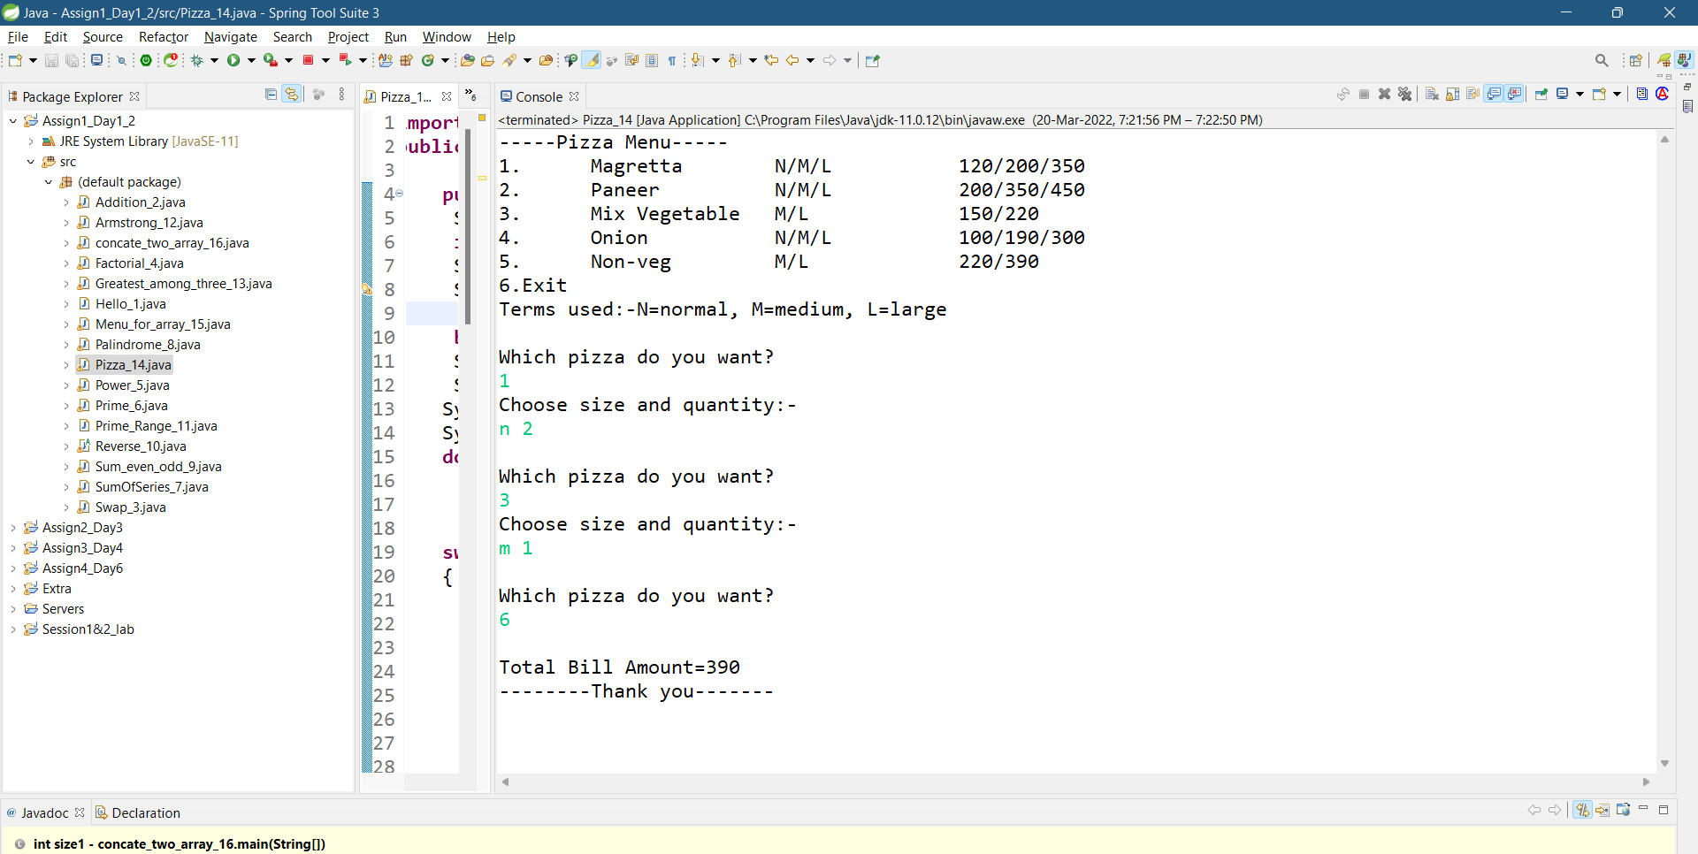

PROGRAM 15 :-

Create Menu driven program for array operations.  
1:Read Array 2:Print Array 3:Search element in array 4:Reverse Array 5:Even number from array6:sum of array element

SOURCE CODE :-  
import java.util.Scanner;

public class Menu_for_array_15 {

public static void main(String[] args) {

Scanner sc = new Scanner(System.in);

System.out.println("Size of array will be:-");

int size = sc.nextInt();

int i;

int[] array = new int[size];

System.out.println("Menu:-1.Read\n2.print\n3.search\n4.Reverse\n5.even\n6.sum");

int ch = sc.nextInt();

switch (ch) {

case 1:

System.out.println("enter array element:-");

for (i = 0; i < size; i++)

array[i] = sc.nextInt();

break;

case 2:

System.out.println("enter array element:-");

for (i = 0; i < size; i++)

array[i] = sc.nextInt();

System.out.println("Elements of an array are:-");

for (i = 0; i < size; i++)

System.out.println(array[i] + " ");

break;

case 3:

System.out.println("enter array element:-");

for (i = 0; i < size; i++)

array[i] = sc.nextInt();

System.out.println("Enter the number you want to search in array:-");

int num = sc.nextInt();

int c = 0;

System.out.println(num);

for (i = 0; i < size; i++) {

if (num == array[i]) {

c++;

break;

}

}

if (c == 1)

System.out.println("searched element is present:- " + num);

else

System.out.println("key is not present " + num);

break;

case 4:

System.out.println("enter array element:-");

for (i = 0; i < size; i++)

array[i] = sc.nextInt();

System.out.println("Reversed Array:-");

for (int j = i - 1; j >= 0; j--)

System.out.println(array[j] + " ");

break;

case 5:

System.out.println("enter array element:-");

for (i = 0; i < size; i++)

array[i] = sc.nextInt();

System.out.println("Even number from Array:- ");

for (i = 0; i < size; i++) {

if (array[i] % 2 == 0)

System.out.println(array[i]);

}

break;

case 6:

System.out.println("enter array element:-");

for (i = 0; i < size; i++)

array[i] = sc.nextInt();

int sum = 0;

System.out.println("Sum of an array is:- ");

for (i = 0; i < size; i++)

sum = sum + array[i];

System.out.println(sum);

break;

}

}

}

OUTPUT :-

1. Read array

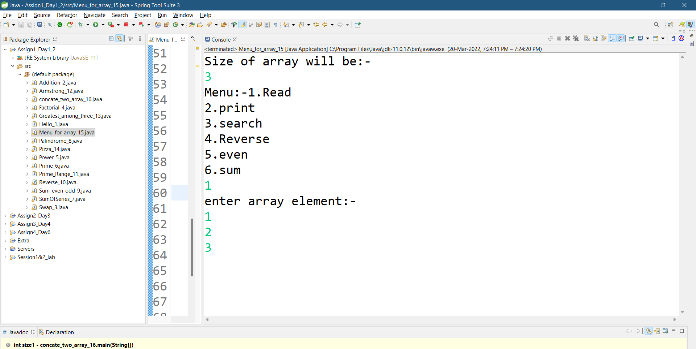

2.Print

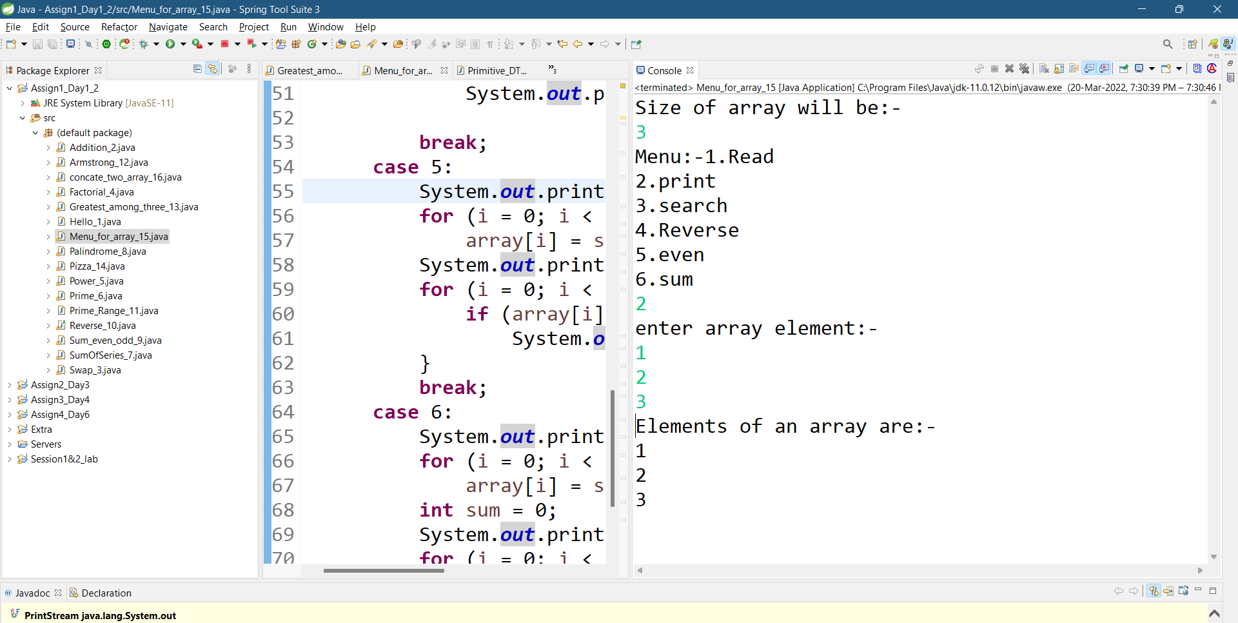

3.Search

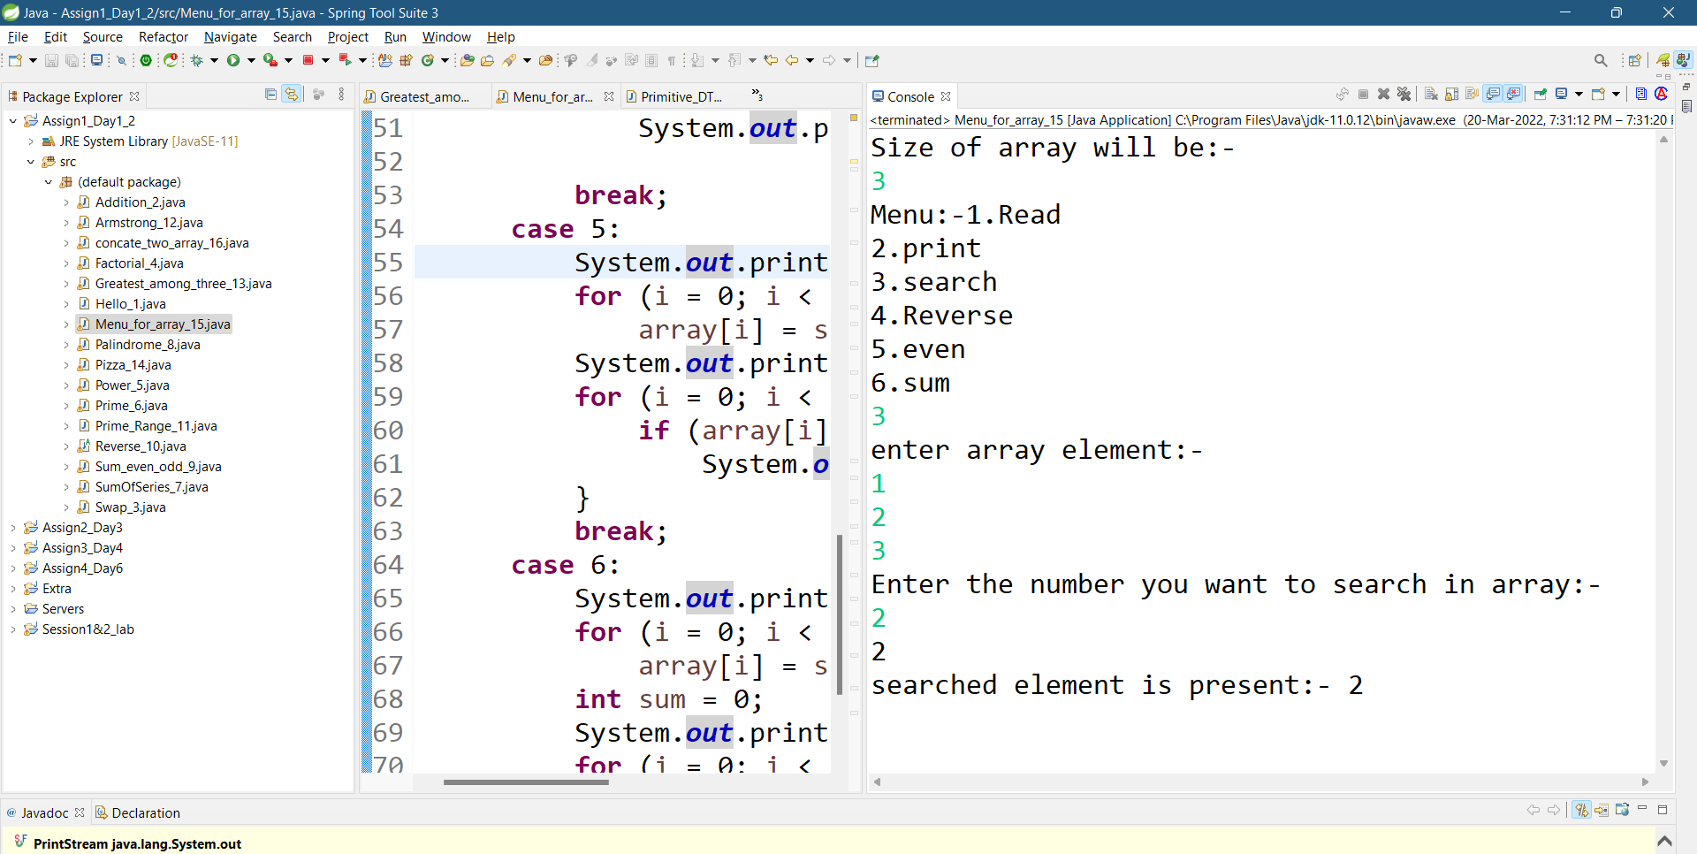

4. Reverse

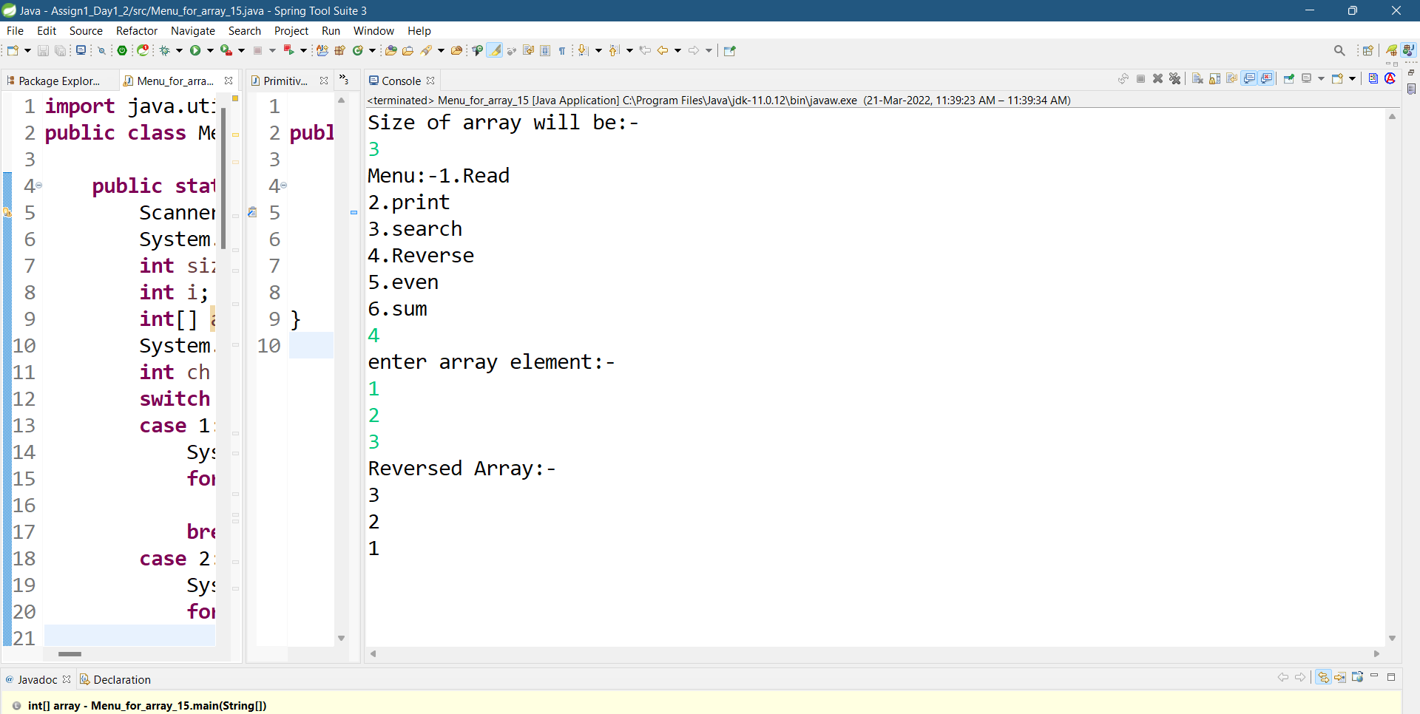

5.Even

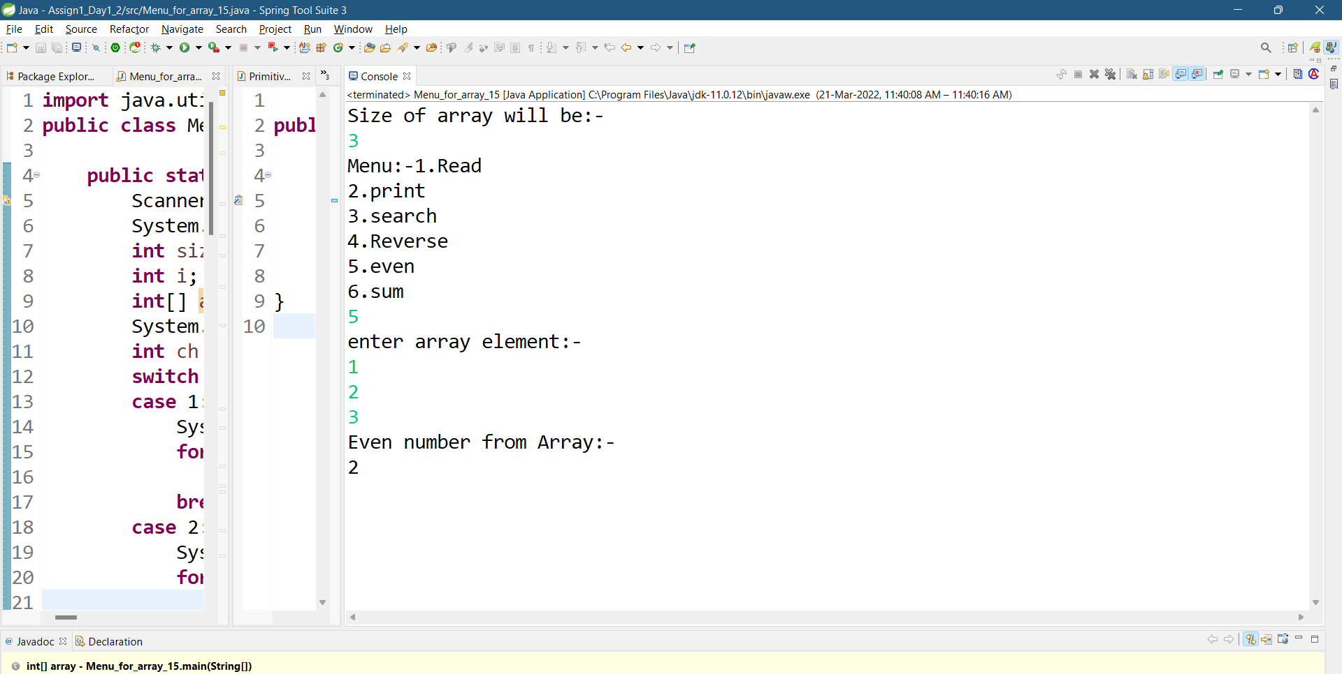

6. Sum

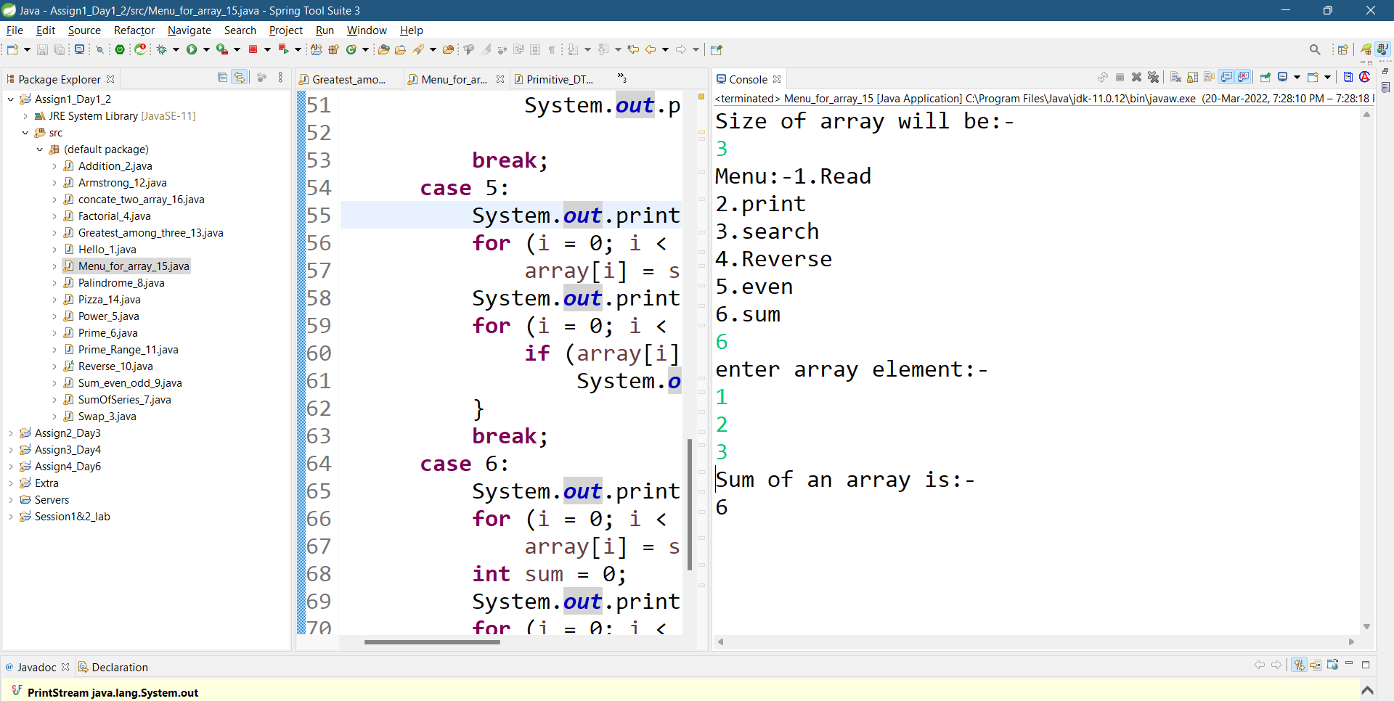

PROGRAM 16:-

read two int array...and store both in third array and display third array  
1 2 3  
5 6 7 8 9  
1 2 3 5 6 7 8 9

SOURCE CODE :-

import java.util.Scanner;

public class concate_two_array_16 {

public static void main(String[] args) {

System.out.println("enter the size of both array:-");

Scanner sc=new Scanner(System.in);

int size1=sc.nextInt();

int size2=sc.nextInt();

int[] array1=new int[size1];

int[] array2=new int[size2];

int[] array3=new int[size1+size2];

System.out.println("Array 1 Element:-");

for(int i=0;i<size1;i++)

array1[i]=sc.nextInt();

for(int i=0;i<size1;i++)

array3[i]=array1[i];

System.out.println("Array 2 Element:-");

for(int i=0;i<size2;i++)

array2[i]=sc.nextInt();

for(int i=0;i<size2;i++)

array3[size1+i]=array2[i];

System.out.println("Array Element after cocatination:-");

for(int i=0;i<(size1+size2);i++)

System.out.print(array3[i]+" ");

}}

OUTPUT :-

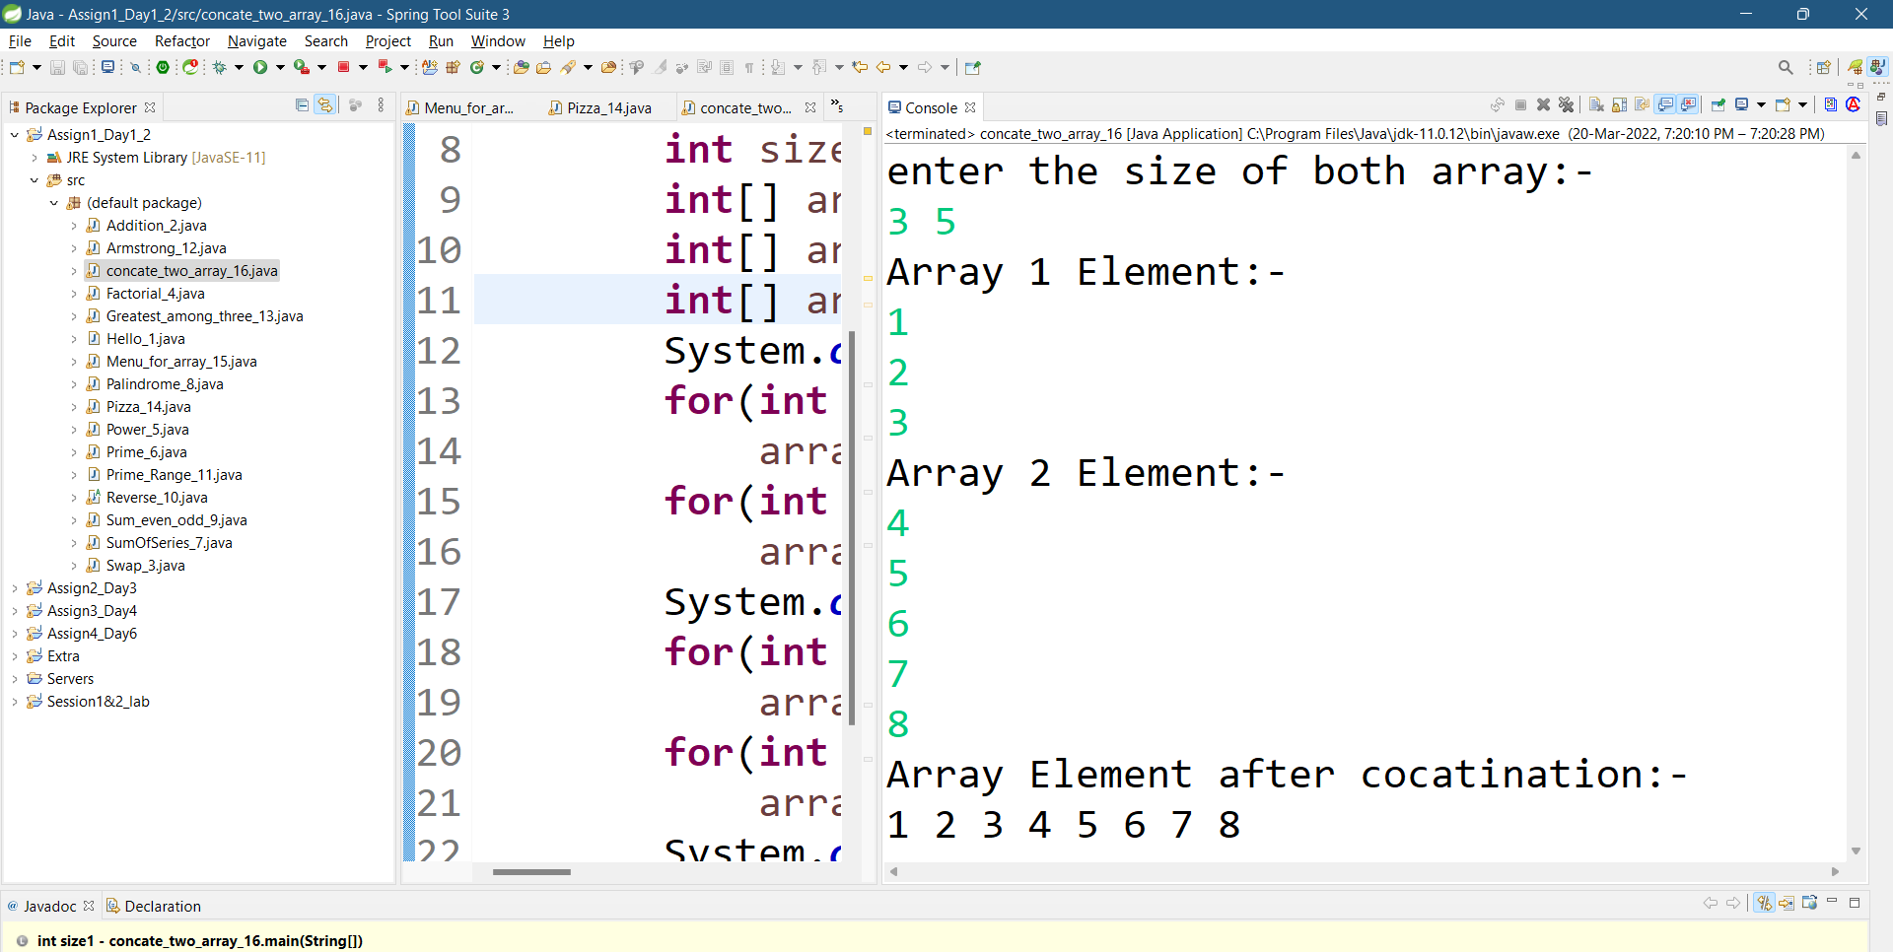

**Day-3 ||Assignment –2**

1:Revise All from theory Session.  
  
PROGRAM 2 :-

Create Date Class with Data Members day,month, year  
2.1:Create an object and initialize it using setDate methods and display it using  
displayDate methods.

CLASS CODE :-

public class Date_2 {

private int day,month,year;

public void setDate(int d,int m,int y)

{

day=d;

month=m;

year=y;

}

public void displayDate()

{

System.out.println("Date:- "+day+"-"+month+"-"+year);

}

}

TESTER CODE :-

import java.util.Scanner;

public class TestDate_2{

public static void main(String[] args)

{

Date_2 obj1;

obj1= new Date_2();

int d,m,y;

Scanner sc=new Scanner(System.in);

System.out.println("Enter the date:- ");

d=sc.nextInt();

m=sc.nextInt();

y=sc.nextInt();

obj1.setDate(d,m,y);

obj1.displayDate();

}}

OUTPUT :-

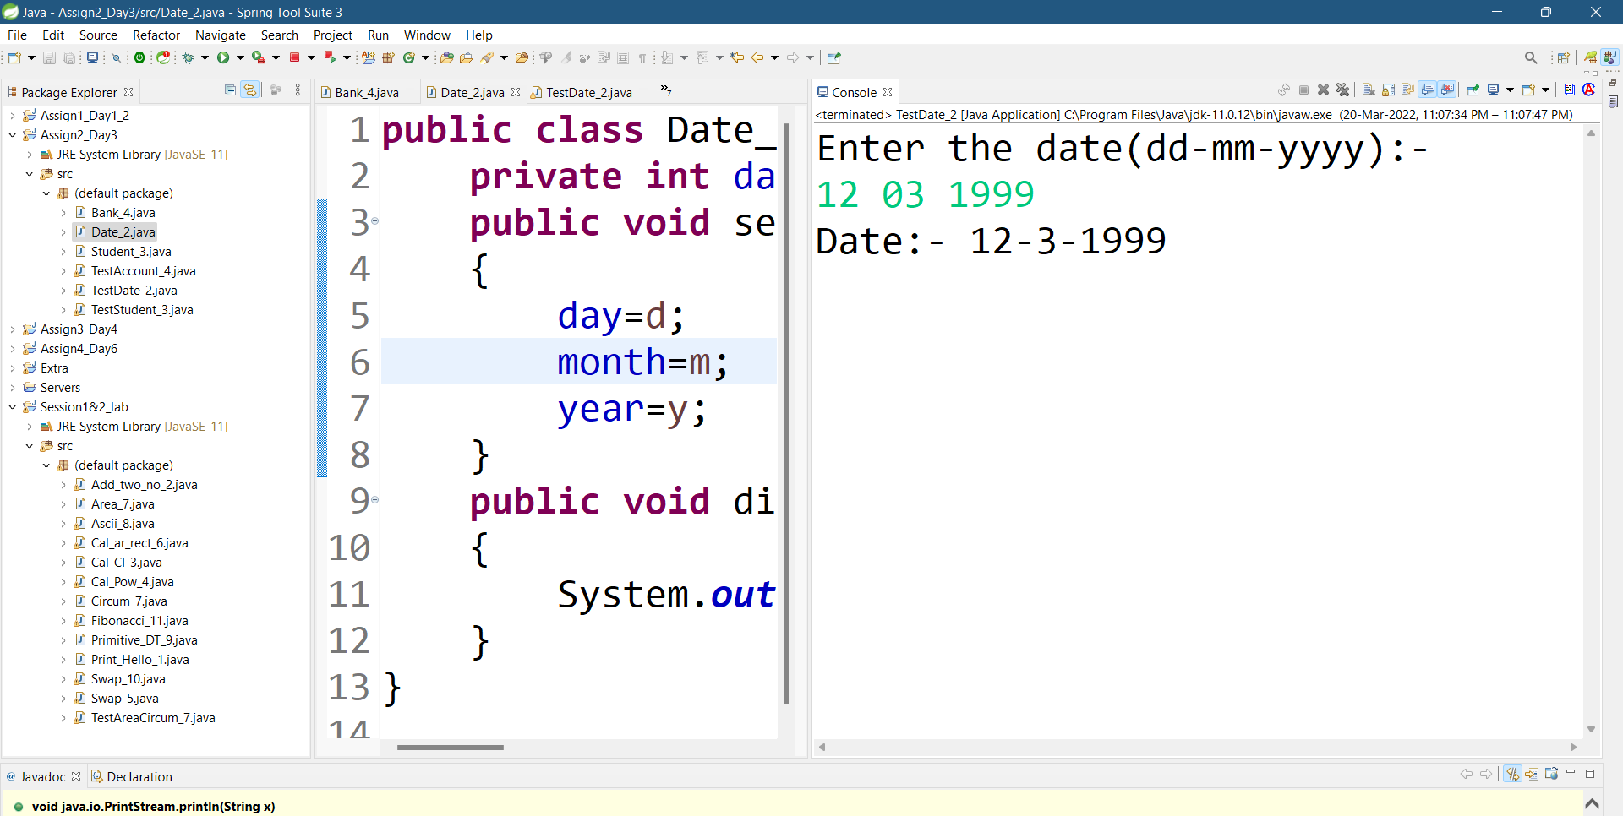

PROGRAM 3 :-

Create Student Class with RollNo,name,totalMarks and Grade  
.Create an object and initialize it using assignStud method and print it using  
printStud method. Create Object of the student and call Methods

CLASS CODE :-

public class Student_3 {

private int rollno,total_marks;

private String name,grade;

void assignStud(int r,int t,String g,String n)

{

rollno=r;

total_marks=t;

grade=g;

name=n;

}

void printStud()

{

System.out.println("Name of the student:-"+name);

System.out.println("Roll number of the student:-"+rollno);

System.out.println("Total Marks of the student:-"+total_marks);

System.out.println("Grade of the student:-"+grade);

}}

TESTER CODE :-

import java.util.Scanner;

public class TestStudent_3 {

public static void main(String[] args) {

Student_3 obj1;

obj1= new Student_3();

Scanner sc=new Scanner(System.in);

System.out.println("Enter roll no. , totol marks, grade, name");

int r=sc.nextInt();

int t=sc.nextInt();

String g=sc.next();

String n=sc.next();

obj1.assignStud(r,t,g,n);

obj1.printStud();

}

}

OUTPUT :-

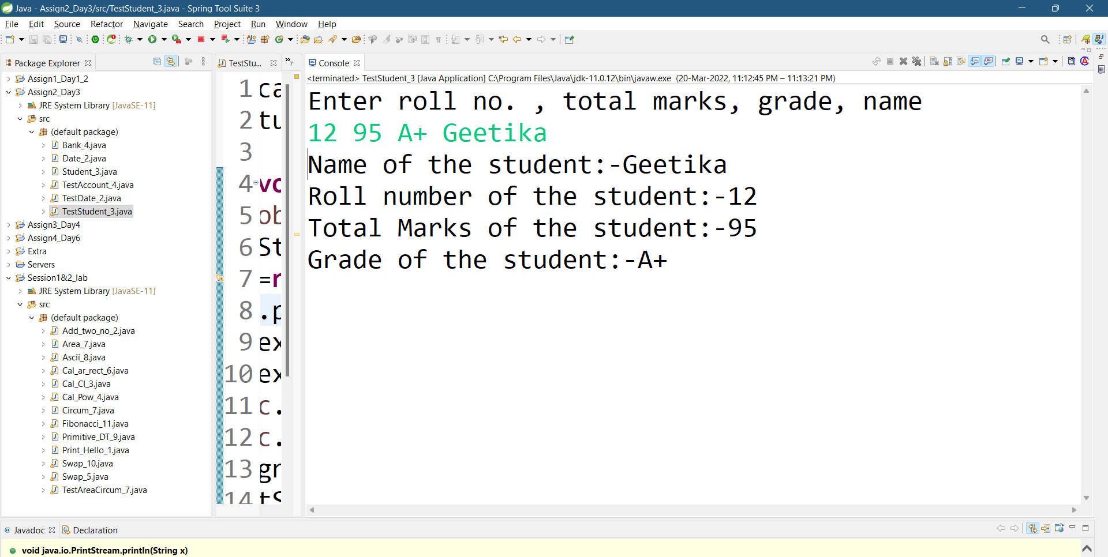

PROGRAM 4 :-

Create java application for bank account handling.  
4.1. Create a class BankAccount -- acct no(int),customer name(string),balance(double)  
 constr to accept all details   
  
4.2 Add Business logic methods  
Methods  
public void withdraw(double amt)   
public void deposit(double amt)  
  
4.3:Create TestAccount class...Create object of account class and test withdraw and deposit methods.

CLASS CODE :-

public class Bank_4 {

private int acct_no;

private String Customer_name;

private double balance,w,d;

public void set(int a,String c,double b)

{

acct_no=a;

Customer_name=c;

balance=b;

}

public void details(){

System.out.println("Account number:- "+acct_no);

System.out.println("Customer Name:- "+Customer_name);

System.out.println("Balance:- "+balance);

}

public void withdraw(double amt)

{

w=balance-amt;

System.out.println("after Withdraw:-"+w);

}

public void deposit(double amt)

{

d=w+amt;

System.out.println("after deposit:-"+d);

}

}

TESTER CODE :-

import java.util.Scanner;

public class TestAccount_4 {

public static void main(String[] args) {

Bank_4 obj1;

obj1= new Bank_4();

Scanner sc=new Scanner(System.in);

System.out.println("enter the details of customer:-");

System.out.println("Account number:- ");

int a=sc.nextInt();

System.out.println("Customer Name:- ");

String ch=sc.next();

System.out.println("Balance:- ");

double b=sc.nextInt();

System.out.println("Enter the amount to withdraw:- ");

double amt=sc.nextInt();

System.out.println("Enter the amount to deposit:- ");

double dep=sc.nextInt();

obj1.set(a, ch, b);

obj1.details();

obj1.withdraw(amt);

obj1.deposit(dep);

}

}

OUTPUT :-

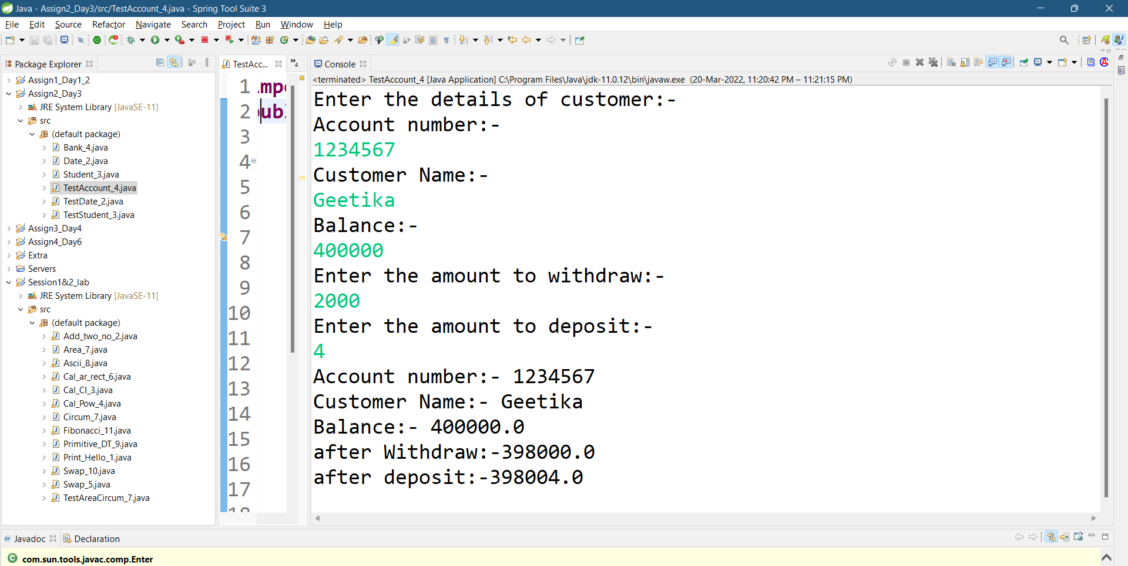

**Day-4|| Assignment-3**

PROGRAM 1 :-

Write a program to create student class with data members rollno, marks1,mark2,mark3.  
Accept data (acceptInfo()) and display using display member function.  
Also display total,percentage and grade.

CLASS CODE :-

public class Student {

private int rollNo,total,marks1 ,marks2,marks3;

private float per;

public void acceptInfo(int r,int m1,int m2,int m3)

{

rollNo=r;

marks1=m1;

marks2=m2;

marks3=m3;

}

private void total()

{

total=marks1+marks2+marks3;

System.out.println("Total Marks = "+total);

}

private void percentage()

{

per= (total*100)/300;

System.out.println("Percentage = "+per+"%");

}

private void grade()

{

if(per<40)

System.out.println("Grade:-Fail");

else if(per>=40&&per<65)

System.out.println("Grade:-C");

else if(per>=65&&per<75)

System.out.println("Grade:-B");

else

System.out.println("Grade:-A");

}

public void display()

{

total();

percentage();

grade();

}}

TESTER CODE :-

import java.util.Scanner;

public class TestStudent {

public static void main(String[] args) {

// TODO Auto-generated method stub

Student std=new Student();

Scanner sc=new Scanner(System.in);

System.out.println("Enter Student details:-");

System.out.println("Roll no:- ");

int rollno=sc.nextInt();

System.out.println("Marks 1:- ");

int marks1=sc.nextInt();

System.out.println("Marks 2:- ");

int marks2=sc.nextInt();

System.out.println("Marks 3:- ");

int marks3=sc.nextInt();

std.acceptInfo(rollno, marks1, marks2, marks3);

std.display();

}

}

OUTPUT :-

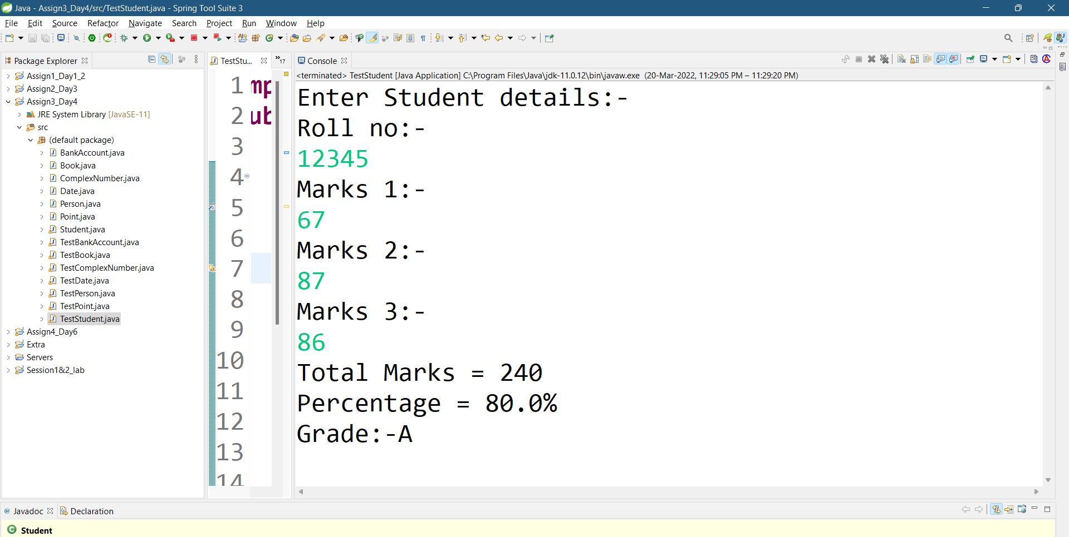

PROGRAM 2 :-

Create a class Person with data members as name, age, city. Write getters and setters for all the data   
members. Also add the display function. Create Default and Parameterized constructors. Create the   
object of this class in main method and invoke all the methods in that class.

CLASS CODE :-

public class Person {

private String name, city;

private int age;

public Person()

{

System.out.println("Name:-"+name);

System.out.println("Age:-"+age);

System.out.println("City:-"+city);

}

public Person(String name, int age, String city)

{

this.name=name;

this.age=age;

this.city=city;

}

public void setName(String name)

{

this.name=name;

}

public void setAge(int age)

{

this.age=age;

}

public void setCity(String city)

{

this.city=city;

}

public String getName()

{

return this.name;

}

public String getCity()

{

return this.city;

}

public int getAge()

{

return this.age;

}

public void display()

{

System.out.println("Name = "+this.name+" Age = "+this.age+" City = "+this.city);

}

}

TESTER CODE :-

import java.util.Scanner;

public class TestPerson {

public static void main(String[] args) {

Person p1=new Person();

Scanner sc=new Scanner(System.in);

System.out.println("----Person Details----");

System.out.println("Name:-");

String name=sc.next();

System.out.println("Age:-");

int age=sc.nextInt();

System.out.println("City:-");

String city=sc.next();

Person p2=new Person(name,age,city);

p2.display();

System.out.println("If yo want to change:-\n1.Name\n2.Age\n3.City\n4.No chnage");

System.out.println("your choice:-");

int choice=sc.nextInt();

switch(choice)

{

case 1:

System.out.println("Enter name");

name=sc.next();

p2.setName(name);

String n=p2.getName();

System.out.println(n);

break;

case 2:

System.out.println("Enter age");

age=sc.nextInt();

p2.setAge(age);

int a=p2.getAge();

System.out.println(a);

break;

case 3:

System.out.println("Enter city");

city=sc.next();

p2.setCity(city);

String c=p2.getCity();

System.out.println(c);

break;

case 4:

System.out.println("Your profile is updated.");

break;

}

p2.display();

}

}

OUTPUT :-

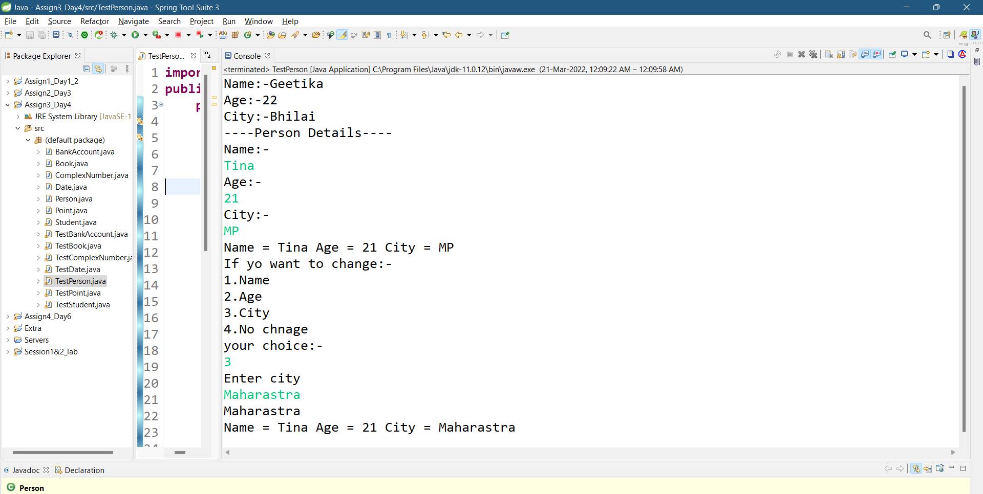

PROGRAM 3 :-

Create a class Date with data members as dd, mm, yy. Write getters and setters for all the data members. Also add the display function. Create Default and Parameterized constructors. Create the   
object of this class in main method and invoke all the methods in that class.

CLASS CODE :-

public class Date {

private int dd,mm,yy;

public Date()

{

System.out.println("Date=14\nMonth=12\nyear=1999");

}

public Date(int day,int month,int year)

{

dd=day;

mm=month;

yy=year;

}

public void setDay(int day)

{

dd=day;

}

public void setMonth(int month){

mm=month;

}

public void setYear(int year)

{

yy=year;

}

public int getDay()

{

return dd;

}

public int getMonth()

{

return mm;

}

public int getYear()

{

return yy;

}

public void display()

{

System.out.println("Date= "+dd+"-"+mm+"-"+yy);

}

}

TESTER CODE :-

import java.util.Scanner;

public class TestDate {

public static void main(String[] args) {

Scanner sc=new Scanner(System.in);

Date d1=new Date();

System.out.println("day month year");

int da=sc.nextInt();

int mm=sc.nextInt();

int yy=sc.nextInt();

Date d2=new Date(da,mm,yy);

System.out.println("if you want to change\n1.Date\n2.Month\n3.Year\n4.Exit");

System.out.println("Your choice:-");

int ch=sc.nextInt();

switch(ch)

{

case 1:

System.out.println("Enter the new date:-");

da=sc.nextInt();

d2.setDay(da);

int a=d2.getDay();

System.out.println(a);

break;

case 2:

System.out.println("Enter the new month:-");

mm=sc.nextInt();

d2.setMonth(mm);

int b=d2.getMonth();

System.out.println(b);

break;

case 3:

System.out.println("Enter the new Year:-");

yy=sc.nextInt();

d2.setDay(yy);

int c=d2.getYear();

System.out.println(c);

break;

case 4:break;

}

System.out.println("Updated date month year is:-");

d2.display();

}

}

OUTPUT :-

1. New date

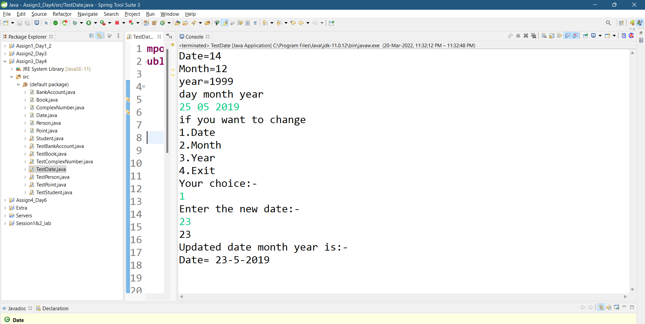

2.change month

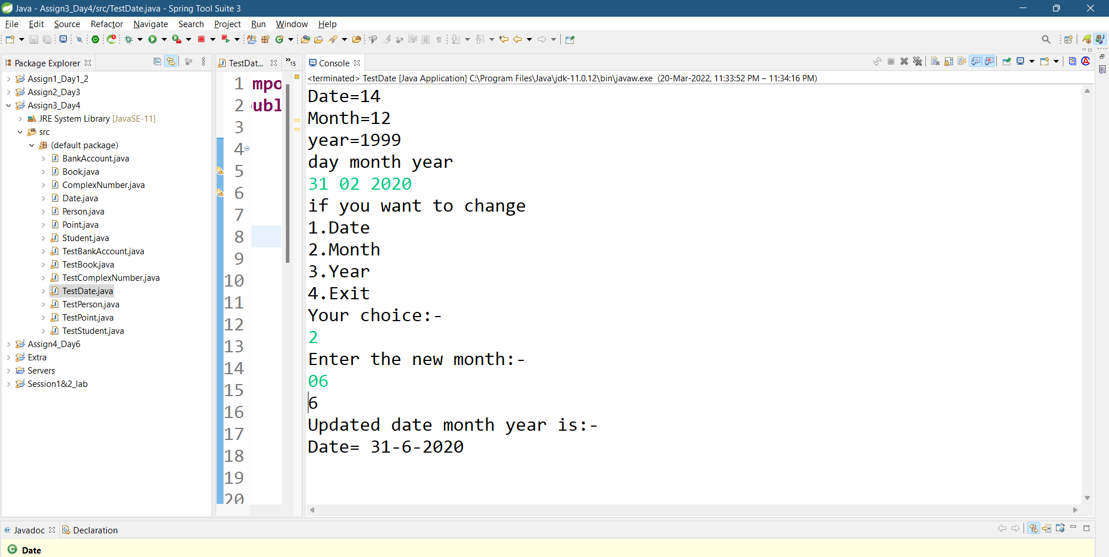

3.change year

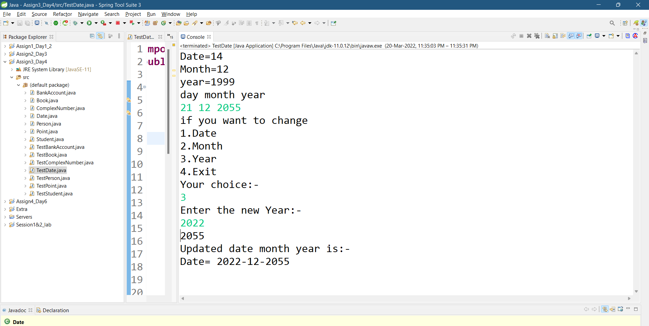

PROGRAM 4 :-

Create a class Book with data members as bname,id,author,price. Write getters and setters for all the   
data members. Also add the display function. Create Default and Parameterized constructors. Create   
the object of this class in main method and invoke all the methods in that class.

CLASS CODE :-

public class Book {

private String bname,author;

private double id,price;

public Book()

{

System.out.println("Must Read this book:-");

System.out.println("Book name=Wings of Fire\nAuthor=A.P.J Abdul Kalam\nId=123321\nPrice:-140");

}

public Book(String bname,double id,String author,double price)

{

this.bname=bname;

this.id=id;

this.author=author;

this.price=price;

}

public void setBname(String bname)

{

this.bname=bname;

}public void setId(double id)

{

this.id=id;

}public void setAuthor(String author)

{

this.author=author;

}public void setPrice(double price)

{

this.price=price;

}

public String getBname()

{

return this.bname;

}

public double getId()

{

return this.id;

}

public String getAuthor()

{

return this.author;

}

public double getPrice()

{

return this.price;

}

public void display()

{

System.out.println("Book Name = "+this.bname+"\nId = "+this.id+"\nAuthor Name = "+this.author+"\nPrice = "+this.price);

}

}

TESTER CODE :-

import java.util.Scanner;

public class TestBook {

public static void main(String[] args) {

Scanner sc=new Scanner(System.in);

Book b1=new Book();

System.out.println("Enter\nbook name:-");

String bname=sc.next();

System.out.println("Enter\nId:-");

double id=sc.nextDouble();

System.out.println("Enter\nAuthor Name:-");

String author=sc.next();

System.out.println("Enter\nPrice:-");

double price=sc.nextDouble();

Book b2=new Book(bname,id,author,price);

System.out.println("If yo want to change:-\n1.Book Name\n2.Id\n3.Author Name\n4.Price\n5.exit for no change");

System.out.println("your choice:-");

int choice=sc.nextInt();

switch(choice)

{

case 1:

System.out.println("Enter new book name");

bname=sc.next();

b2.setBname(bname);

String n=b2.getBname();

System.out.println(n);

break;

case 2:

System.out.println("Enter new id number");

id=sc.nextDouble();

b2.setId(id);

double b=b2.getId();

System.out.println(b);

break;

case 3:

System.out.println("Enter new Author name");

author=sc.next();

b2.setAuthor(author);

String c=b2.getAuthor();

System.out.println(c);

break;

case 4:

System.out.println("Enter new price");

price=sc.nextDouble();

b2.setPrice(price);

double d=b2.getPrice();

System.out.println(d);

break;

case 5:

System.out.println("Your data is updated.");

break;

}

b2.display();

}}

OUTPUT :-

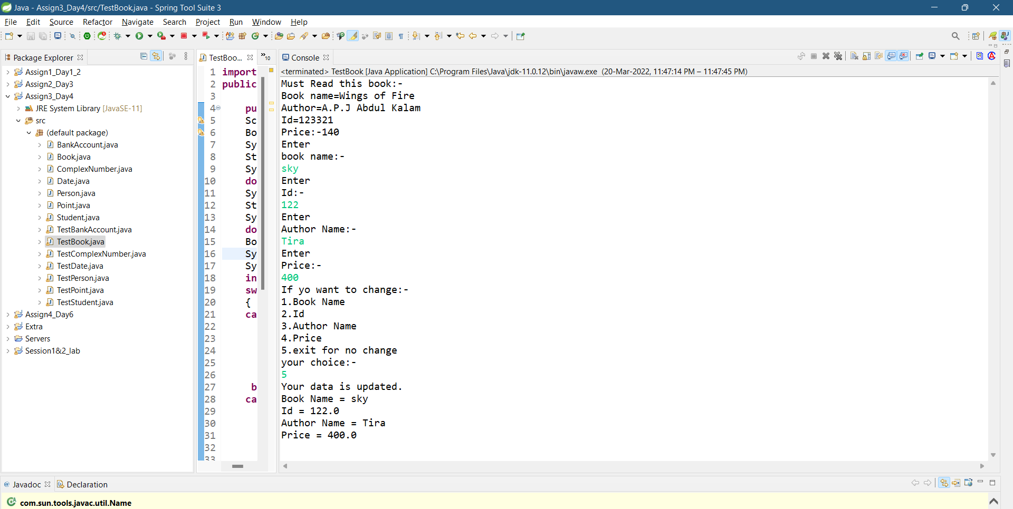

PROGRAM 5 :-

Create a class Point with data members as x,y. Create Default and Parameterized constructors. Write   
getters and setters for all the data members. Also add the display function. Create the object of this   
class in main method and invoke all the methods in that class.

CLASS CODE :-

public class Point {

private int x,y;

public Point()

{

System.out.println("x=20,y=20");

}

public Point(int a,int b)

{

x=a;

y=b;

}

public void setX(int a)

{

x=a;

}

public void setY(int b)

{

y=b;

}

public int getX()

{

return x;

}

public int getY()

{

return y;

}

public void display()

{

System.out.println("x = "+x+" y = "+y);

}

}

TESTER CODE :-

import java.util.Scanner;

public class TestPoint {

public static void main(String[] args) {

Scanner sc=new Scanner(System.in);

Point p1=new Point();

System.out.println("enter the value\nx=");

int x=sc.nextInt();

System.out.println("y=");

int y=sc.nextInt();

Point p2=new Point(x,y);

System.out.println("if you want to change\n1.X\n2.Y\n3.Exit");

System.out.println("Your choice:-");

int ch=sc.nextInt();

switch(ch)

{

case 1:

System.out.println("Enter the new x:-");

x=sc.nextInt();

p2.setX(x);

int a=p2.getX();

System.out.println(a);

break;

case 2:

System.out.println("Enter the new y:-");

y=sc.nextInt();

p2.setY(y);

int b=p2.getY();

System.out.println(b);

break;

case 3:break;

}

System.out.println("Updated X and Y is:-");

p2.display();

}

}

OUTPUT :-

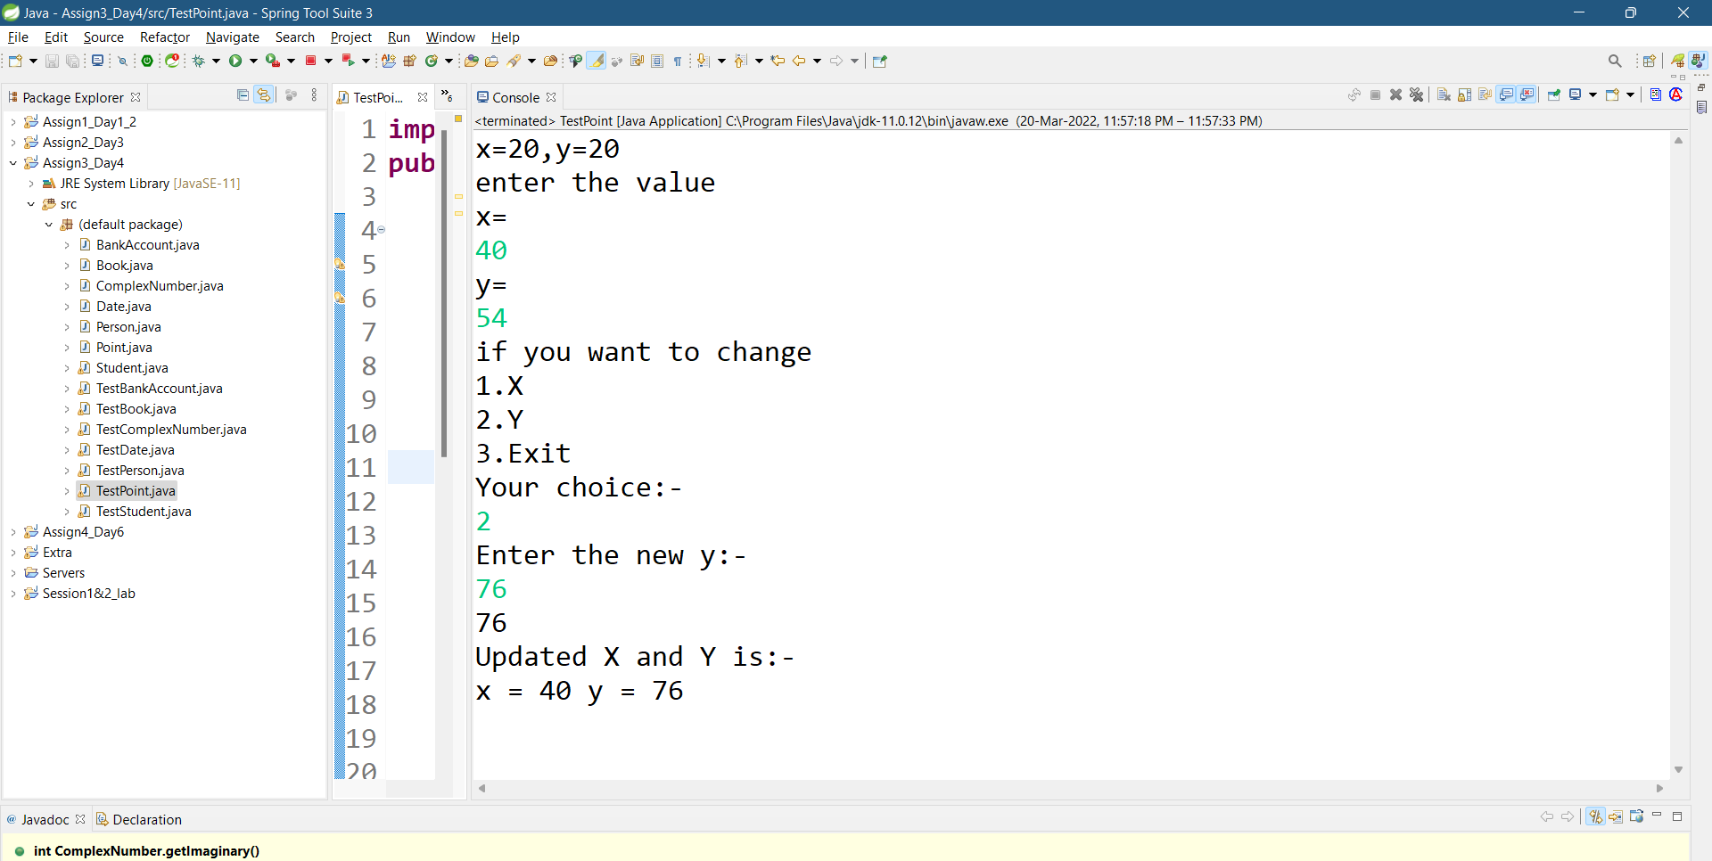

PROGRAM 6 :-

Create a class ComplexNumber with data members real, imaginary. Create Default and Parameterized constructors. Write getters and setters for all the data members. Also add the display function. Create the object of this class in main method and invoke all the methods in that class.

CLASS CODE :-

public class ComplexNumber {

private int real,imaginary;

public ComplexNumber()

{

System.out.println("if 30+20i then :- r=30,i=20");

}

public ComplexNumber(int a,int b)

{

real=a;

imaginary=b;

}

public void setReal(int a)

{

real=a;

}

public void setImaginary(int b)

{

imaginary=b;

}

public int getReal()

{

return real;

}

public int getImaginary()

{

return imaginary;

}

public void display()

{

System.out.println("Real = "+real+" Imaginary = "+imaginary+"i");

}

}

TESTER CODE :-

import java.util.Scanner;

public class TestComplexNumber {

public static void main(String[] args) {

Scanner sc=new Scanner(System.in);

ComplexNumber p1=new ComplexNumber();

System.out.println("enter the value\nx=");

int x=sc.nextInt();

System.out.println("y=");

int y=sc.nextInt();

ComplexNumber p2=new ComplexNumber(x,y);

System.out.println("if you want to change\n1.Real\n2.Imaginary\n3.Exit");

System.out.println("Your choice:-");

int ch=sc.nextInt();

switch(ch)

{

case 1:

System.out.println("Enter the new Real number:-");

x=sc.nextInt();

p2.setReal(x);

int a=p2.getReal();

System.out.println(a);

break;

case 2:

System.out.println("Enter the new Imaginary number:-");

y=sc.nextInt();

p2.setImaginary(y);

int b=p2.getImaginary();

System.out.println(b);

break;

case 3:break;

}

System.out.println("Updated Complex Number is:-");

p2.display();

}

}

OUTPUT :-

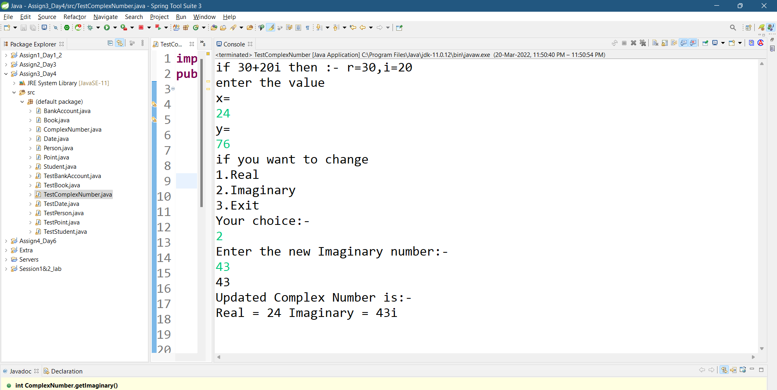

PROGRAM 7 :-   
Create BankAccount aaplication for operations like withdraw ,deposite and moneyTransfer.  
Create menu drive program for bank operations..

CLASS CODE :-

public class BankAccount {

private static int sno;

private double acc_no,balance;

private String email,name;

public static void Sno()

{

System.out.println("Customer "+(sno+=1)+":-");

}

public BankAccount()

{

System.out.println("Minimum balance must be = 2000");

}

public BankAccount(double acc_no,String name ,String email,double balance)

{

this.acc_no=acc_no;

this.name= name;

this.email=email;

this.balance=balance;

}

public void setName(String name)

{

this.name=name;

}

public void setEmail(String email)

{

this.email=email;

}

public double getAccountNumber()

{

return acc_no;

}

public void Deposite(double amount)

{

this.balance=this.balance+ amount;

}

public void Withdraw(double amount)

{

this.balance=this.balance-amount;

}

public void Transfer(double amount,double receiver)

{

this.balance= this.balance-amount;

}

public void display()

{

System.out.println(acc_no+" "+name+" "+email+" "+balance);

}

}

TESTER CODE :-

import java.util.Scanner;

public class TestBankAccount {

public static void main(String[] args) {

Scanner sc = new Scanner(System.in);

BankAccount b1 = new BankAccount();

BankAccount[] axisBank = new BankAccount[5];

int a;

System.out.println("Enter account details Account number,Name,Email,Balance of 5 person.");

for(int i=0;i<axisBank.length;i++)

{

axisBank[i] = new BankAccount(sc.nextDouble(), sc.next(),

sc.next(), sc.nextDouble());

}

System.out.println("Details of entered customer are:-");

for(int i=0;i<axisBank.length;i++)

{

BankAccount.Sno();

axisBank[i].display();

}

do

{

System.out.println("Enter your choice:-\n1.Edit your profile.\n2.Banking.\n3.Exit Press 0");

a=sc.nextInt();

switch(a)

{

case 1:

System.out.println("1.Name\n2.Email");

int b=sc.nextInt();

switch(b)

{

case 1:

System.out.println("Enter your account number:-");

double cc=sc.nextDouble();

for(int i=0;i<axisBank.length;i++)

{

if(axisBank[i].getAccountNumber()==cc)

{

System.out.println("new name:-");

String name=sc.next();

axisBank[i].setName(name);

axisBank[i].display();

}

}

break;

case 2:

System.out.println("Enter your account number:-");

double cd=sc.nextDouble();

for(int i=0;i<axisBank.length;i++)

{

if(axisBank[i].getAccountNumber()==cd)

{

System.out.println("new email:-");

String email=sc.next();

axisBank[i].setEmail(email);

axisBank[i].display();

}

}

break;

}

System.out.println("-----------------------");

break;

case 2:

System.out.println("1.Withdraw\n2.Deposit\n3.Transfer");

int c=sc.nextInt();

switch(c)

{

case 1:

System.out.println("Enter your account number:-");

double ce=sc.nextDouble();

for(int i=0;i<axisBank.length;i++)

{

if(axisBank[i].getAccountNumber()==ce)

{

System.out.println("Amount you want to withdraw:-");

axisBank[i].Withdraw(sc.nextDouble());

axisBank[i].display();

}

}

break;

case 2:

System.out.println("Enter your account number:");

double cf=sc.nextDouble();

for(int i=0;i<axisBank.length;i++)

{

if(axisBank[i].getAccountNumber()==cf)

{

System.out.println("Amount you want to deposit:-");

axisBank[i].Deposite(sc.nextDouble());

axisBank[i].display();

}

}

break;

case 3:

System.out.println("Enter your account number:-");

double cg=sc.nextDouble();

for(int i=0;i<axisBank.length;i++)

{

if(axisBank[i].getAccountNumber()==cg)

{

System.out.println("Amount you want to transfer and amount of receiver :-");

axisBank[i].Transfer(sc.nextDouble(),sc.nextDouble());

axisBank[i].display();

}

}

break;

}System.out.println("----------------------");

}}while(a!=0);

System.out.println("!!!Thank You!!!");

}}

OUTPUT :-

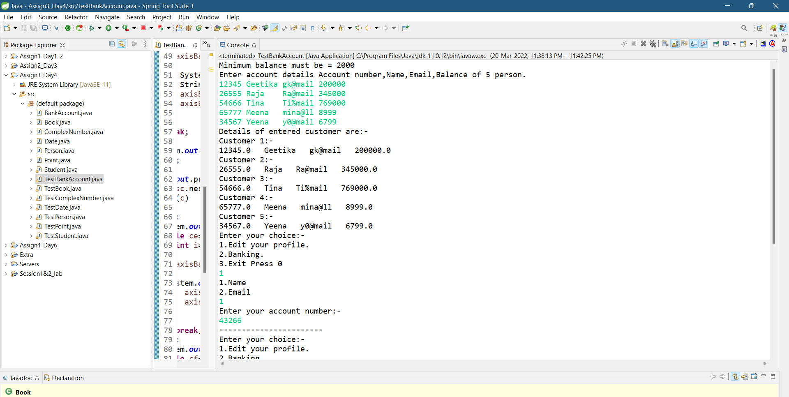

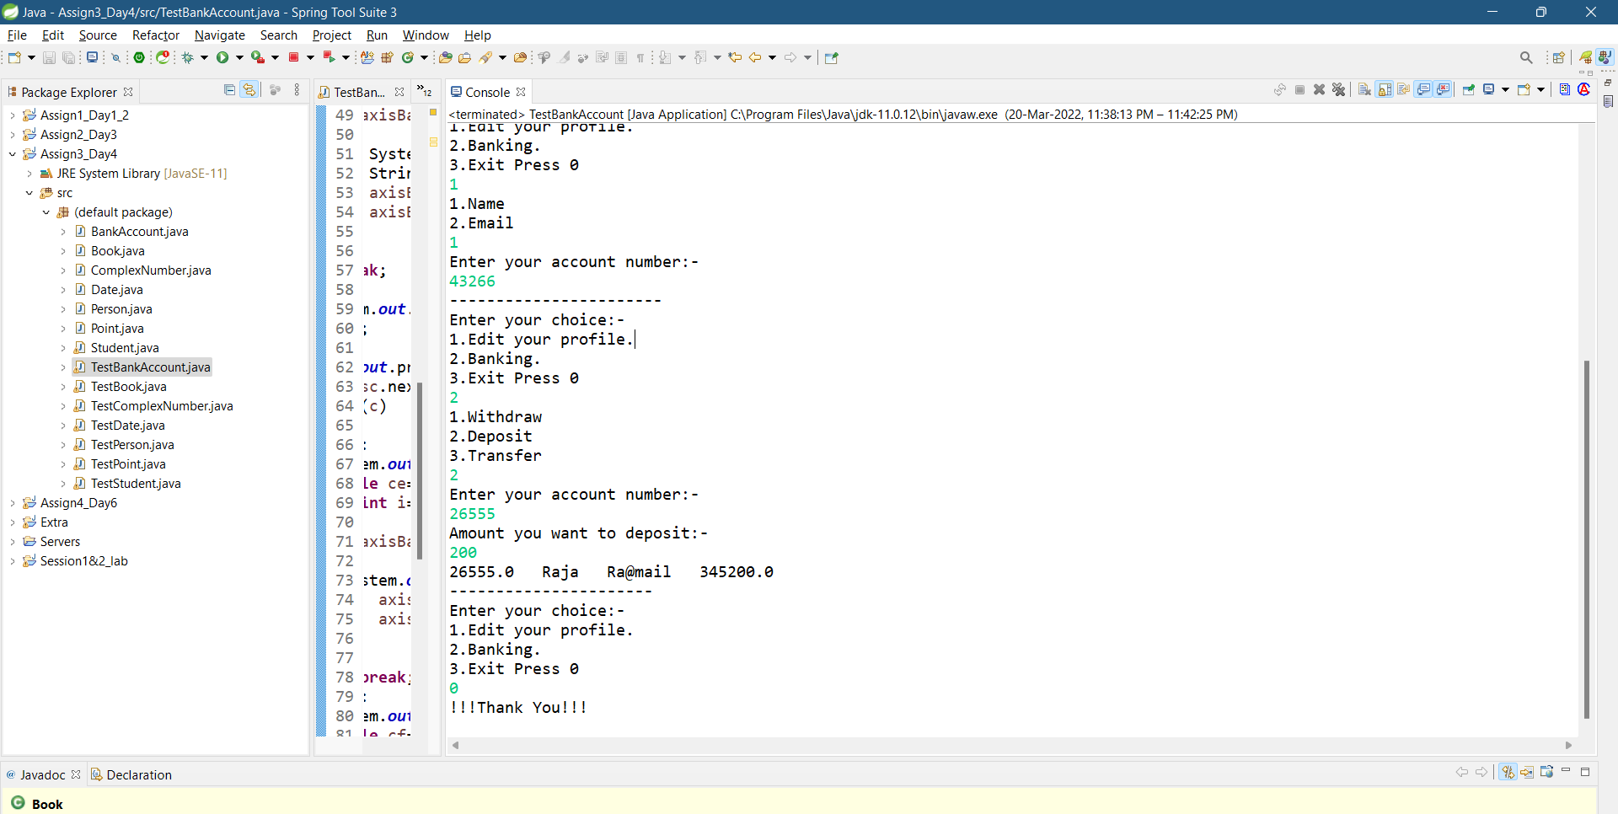

PROGRAM 8 :-

Create array of BankAccount class and store 5 objects....create menu driven application for same.....ex. show all account names ,balance,email..

CLASS CODE :-

public class Array {

private double acc_no,balance;

private String email,name;

public Array()

{

System.out.println("Minimum balance must be = 2000");

}

public Array(double acc_no,String name ,String email,double balance)

{

this.acc_no=acc_no;

this.name= name;

this.email=email;

this.balance=balance;

}

public void setName(String name)

{

this.name=name;

}

public void setEmail(String email)

{

this.email=email;

}

public double getAccountNumber()

{

return acc_no;

}

public void display()

{

System.out.println(acc_no+" "+name+" "+email+" "+balance);

}

}

TESTER CODE :-

import java.util.Scanner;

public class TestArray {

public static void main(String[] args) {

Array[] r= new Array[5];

Scanner sc= new Scanner(System.in);

System.out.println("enter the details of 5 person(account no.,name,email,balance)");

for(int i=0;i<r.length;i++)

{

r[i]=new Array(sc.nextDouble(), sc.next(), sc.next(), sc.nextDouble());

}

for(Array i:r)

{

i.display();

}

System.out.println("Enter your choice if you want to change:-\n1.Name\n2.Email\n3.Exit");

int a=sc.nextInt();

switch(a)

{

case 1:

System.out.println("Enter your account number:-");

double cc=sc.nextDouble();

for(int i=0;i<r.length;i++)

{

if(r[i].getAccountNumber()==cc)

{

System.out.println("new name:-");

String name=sc.next();

r[i].setName(name);

r[i].display();

}

}

break;

case 2:

System.out.println("Enter your account number:-");

double cd=sc.nextDouble();

for(int i=0;i<r.length;i++)

{

if(r[i].getAccountNumber()==cd)

{

System.out.println("new email:-");

String email=sc.next();

r[i].setEmail(email);

r[i].display();

}

}

break;

case 3:System.out.println("-----Thank you----");

break;

}

}

}

OUTPUT :-

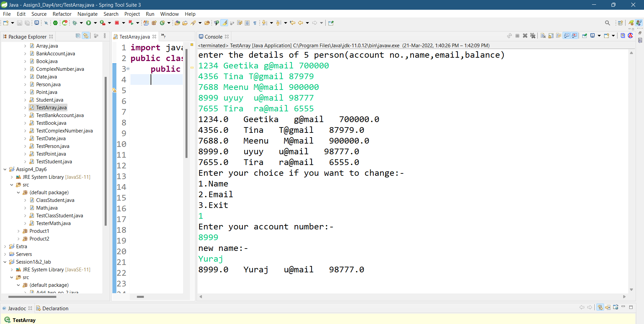

**Day-6|| Assignment-4**

PROGRAM 1:-

Create Student class with rollno,name address.  
Write business logic for auto incrment of rollno(don't accept roll no from user)  
Write parameterised constr for accepting name and address only  
Write getter and setter and display function  
1.1 Test Student class by creating 5 diff object.and display aal details(chk rollno created automatically)  
1.2 Create an array of 5 students and show only names   
1.3 modify 1.2 for showing students details who lives in Pune

CLASS CODE :-

public class ClassStudent {

private int roll_no;

public static int count=0;

private String name,address;

public ClassStudent(String name,String address)

{

this.roll_no=count;

this.name=name;

this.address=address;

count++;

}

public void setName(String name)

{

this.name=name;

}

public void setAddress(String address)

{

this.address=address;

}

public String getName()

{

return this.name;

}

public String getAddress()

{

return this.address;

}

public void display()

{

System.out.println(roll_no+" "+name+" "+address);

}

}

TESTER CODE :-

import java.util.Scanner;

public class TestClassStudent {

public static void main(String[] args) {

// TODO Auto-generated method stub

Scanner sc=new Scanner(System.in);

System.out.println("enter the details of 5 student ie name and address:-");

ClassStudent[] c1=new ClassStudent[5];

for(int i=0;i<c1.length;i++)

{

c1[i]=new ClassStudent(sc.next(),sc.next());

}

System.out.println("Rno Name Address");

for(ClassStudent s:c1)

{

s.display();

}

System.out.println("----If you want to change----\n1.Name\n2.Address\n3.exit");

int ch=sc.nextInt();

switch(ch)

{

case 1:

System.out.println("enter previous name to change:-");

String r=sc.next();

for(int i=0;i<c1.length;i++)

{

if(c1[i].getName().equals(r))

{

System.out.println("new name:-");

String name=sc.next();

c1[i].setName(name);

}

}

break;

case 2:

System.out.println("enter previous address to change:-");

String ad=sc.next();

for(int i=0;i<c1.length;i++)

{

if(c1[i].getAddress().equals(ad))

{

System.out.println("New Address:-");

String address=sc.next();

c1[i].setAddress(address);

}

}

break;

case 3: break;

}

System.out.println("----Names are----");

for(ClassStudent s:c1)

{

System.out.println(s.getName());

}

System.out.println("----Address are----");

for(ClassStudent d:c1)

{

System.out.println(d.getAddress());

}

System.out.println("Students who lives in pune:-");

System.out.println("Rno Name Address");

for(int i=0;i<c1.length;i++)

{

if(c1[i].getAddress().equalsIgnoreCase("pune"))

{

c1[i].display();

}

}

System.out.println("!!!Successfull Execution done!!!");

}

}

OUTPUT :-

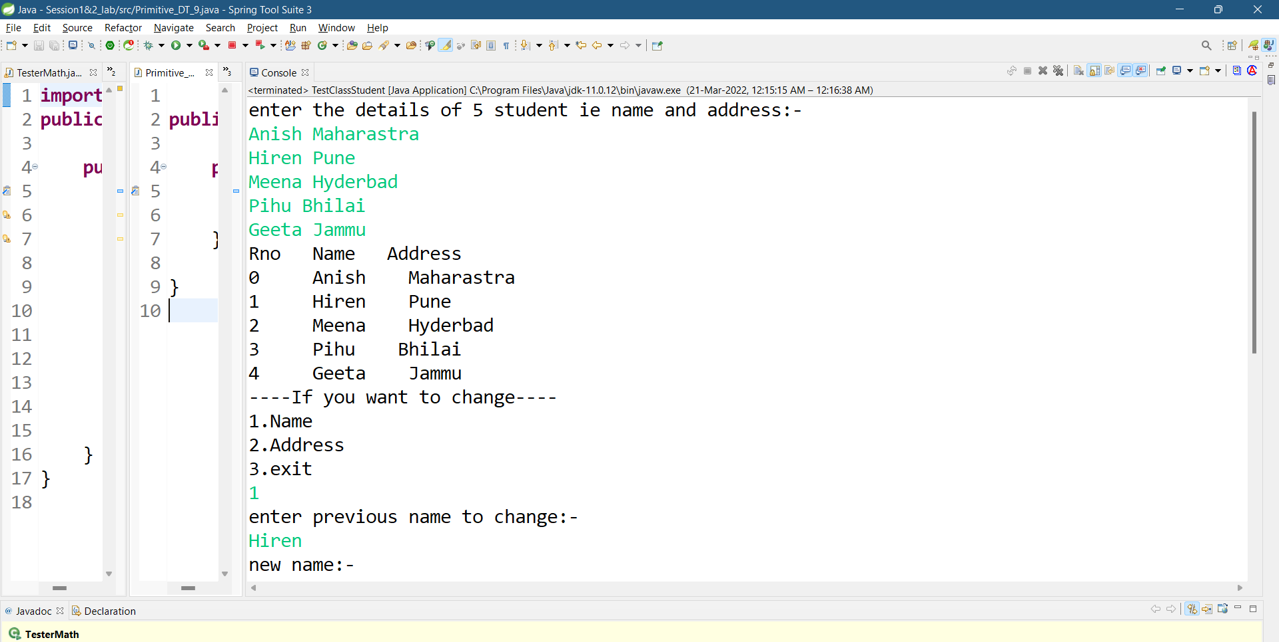

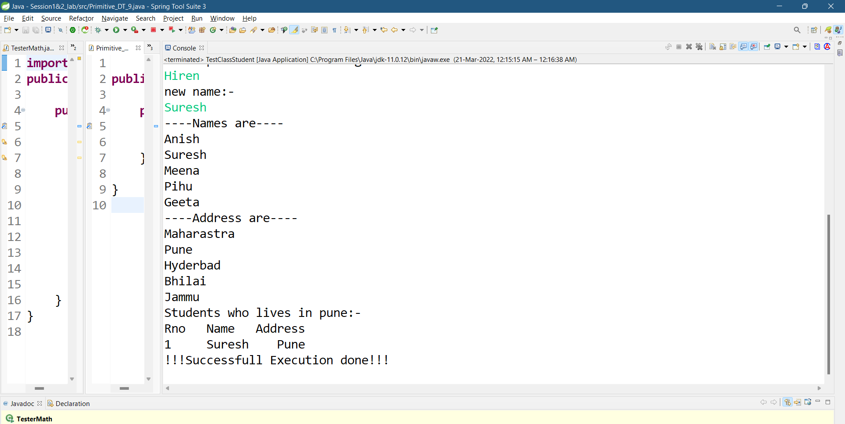

PROGRAM 2 :-

Create Math class for testing MethodOverloading Concept  
Test it using tesrter class

CLASS CODE :-

public class Math {

public static void Add(int a,double b)

{

System.out.println("Integer and double Addition:- "+(a+b));

}

public static void Add(int a,int b,int c)

{

System.out.println("Three Integer Addition:- "+(a+b+c));

}

public static void Add(double a,double b)

{

System.out.println("Double Addition:- "+(a+b));

}

public static void Add(String a,int b)

{

System.out.println("Character and integer addition:-"+('a'+b));

}

}

TESTER CODE :-

import java.util.Scanner;

public class TesterMath {

public static void main(String[] args) {

// TODO Auto-generated method stub

Scanner sc=new Scanner(System.in);

Math m=new Math();

System.out.println("Enter first value of interger type and second value of double type:-");

Math.Add(sc.nextInt(),sc.nextDouble());

System.out.println("\nEnter three values of interger type:-");

Math.Add(sc.nextInt(),sc.nextInt(),sc.nextInt());

System.out.println("\nEnter two values of double type:-");

Math.Add(sc.nextDouble(),sc.nextDouble());

System.out.println("\nEnter first value of character type and second value of integer type:-");

Math.Add(sc.next(),sc.nextInt());

}

}

OUTPUT :-

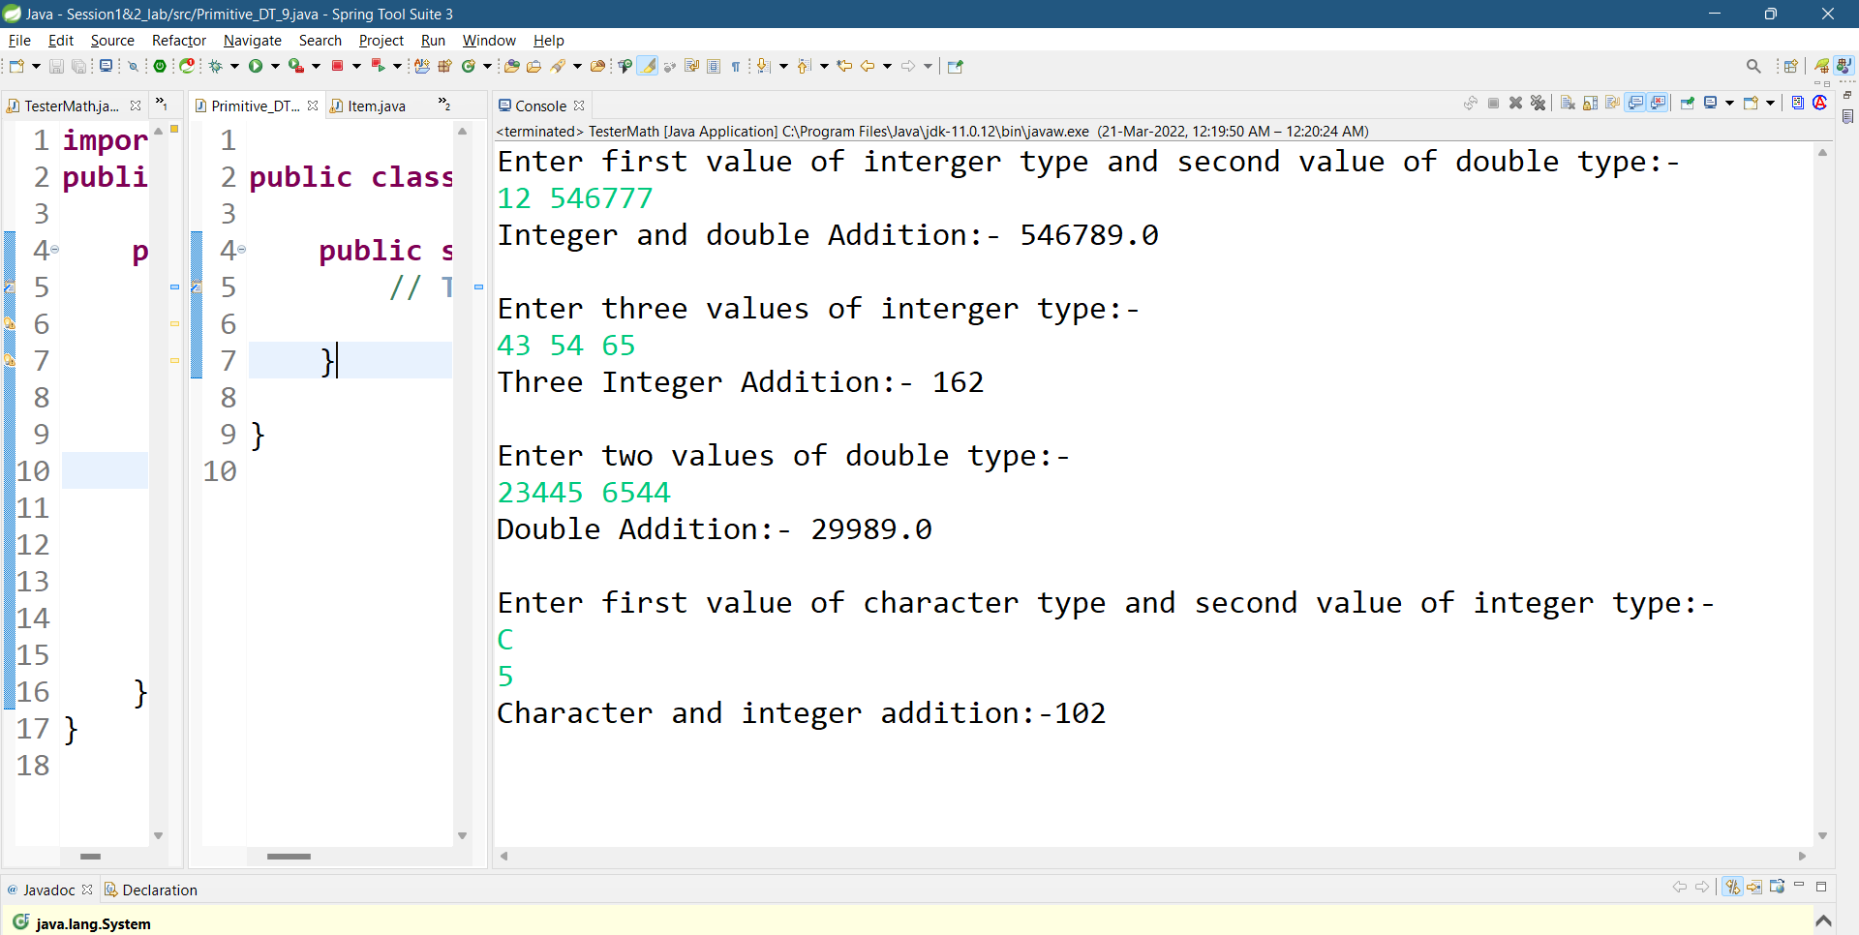

PROGRAM 3 :-

Create diff package and add class inside that.  
Try to access one package class in another package....  
(chk default access specifier)

PAKAGE 1:-

Class Code :-

package Product1;

public class Item {

private int addItem,sum=0;

private String pname;

void Item()

{

System.out.println("Book Choice :-");

}

public Item()

{

System.out.println("---------Welcome to shop -------");

System.out.println("1.Java Rs 400\n2.OS Rs 420\n3.C Rs 180\n4.C++ Rs200");

}

public void item(String pname,int addItem)

{

this.pname=pname;

this.addItem=addItem;

}

public String getPname()

{

return this.pname;

}

public int getItem()

{

return this.addItem;

}

public void Calculate(String n,int b)

{

if(n.equalsIgnoreCase("java"))

{

sum=b*400;

}

else if(n.equalsIgnoreCase("os"))

{

sum=b*420;

}

else if(n.equalsIgnoreCase("c"))

{

sum=b*180;

}

else if(n.equalsIgnoreCase("c++"))

{

sum=b*200;

}

}

public void display()

{

System.out.println(+sum);

}

public int getBill()

{

return sum;

}

}

Tester Code :-

package Product1;

import java.util.Scanner;

public class TestItem1 {

public static void main(String[] args) {

// TODO Auto-generated method stub

Scanner sc=new Scanner(System.in);

Item i=new Item();

i.Item(); // default method

System.out.println("Enter book name and add item number");

i.item(sc.next(),sc.nextInt());

i.Calculate(i.getPname(),i.getItem());

System.out.println("Your First Bill is:-");

i.display();

}

}

PACKAGE 2 :-

Class Code :-

package Product2;

public class Snacks {

private int addItem,sum1=0;

private String name;

void Snacks()

{

System.out.println("Book Choice :-");

}

public Snacks()

{

System.out.println("---------Welcome to shop -------");

System.out.println("1.Maggie Rs 50\n2.Sandwich Rs 80\n3.Pasta Rs 120\n4.Mocktail Rs200");

}

public void snacks(String name,int addItem)

{

this.name=name;

this.addItem=addItem;

}

public String getSname()

{

return this.name;

}

public int getItem()

{

return this.addItem;

}

public void Calculate(String n,int b)

{

if(n.equalsIgnoreCase("Maggie"))

{

sum1=b*50;

}

else if(n.equalsIgnoreCase("Sandwich"))

{

sum1=b*80;

}

else if(n.equalsIgnoreCase("Pasta"))

{

sum1=b*120;

}

else if(n.equalsIgnoreCase("Mocktail"))

{

sum1=b*200;

}

}

public void display()

{

System.out.println(+sum1);

}

public int getBill()

{

return sum1;

}

}

Tester Code :-

package Product2;

import java.util.Scanner;

import Product1.Item;

import Product1.TestItem1;

public class Bill {

public static void main(String[] args) {

Item i=new Item();

Snacks s=new Snacks();

Scanner sc=new Scanner(System.in);

System.out.println("Enter book name and add item number");

i.item(sc.next(),sc.nextInt());

i.Calculate(i.getPname(),i.getItem());

System.out.println("Enter Snacks name and add item number");

s.snacks(sc.next(),sc.nextInt());

s.Calculate(s.getSname(),s.getItem());

System.out.println("Books Bill is:-");

i.display();

System.out.println("Snaks Bill is:-");

s.display();

System.out.println("Your total bill = "+(i.getBill()+s.getBill()));

}

}

OUTPUT :-

1.Package 1 output :-

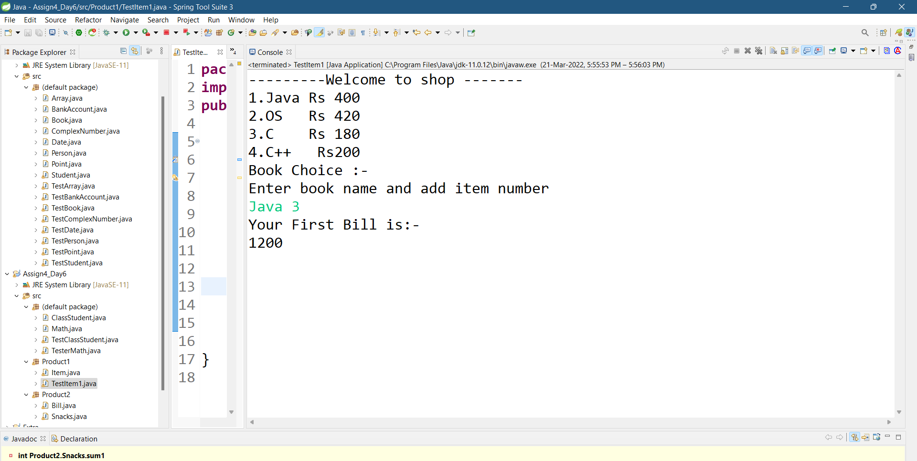

2.Pacakage 2 output:-

